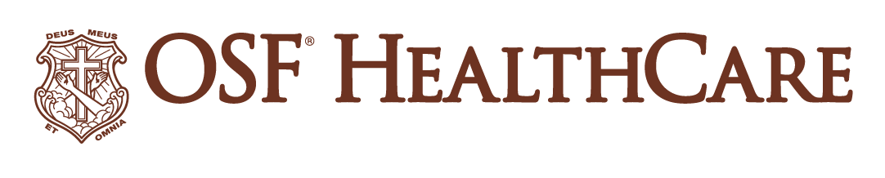
OSF HealthCare expanding primary care to Monticello
FOR IMMEDIATE RELEASE
Contact: Tim Ditman, OSF HealthCare Media Relations Coordinator | (309) 838-9664
Note for reporters: A digital version of this release with photos, b-roll and more is available here.

(October 8, 2024 | Monticello, Illinois) – Residents in the Monticello, Illinois, area will soon have increased access to primary care through a new OSF Medical Group clinic at 777 Bridge Street.
Amber Oberheim, APN, a longtime Monticello resident, is expected to begin seeing patients this winter. People of all ages can see Oberheim for a variety of primary care issues including annual physicals, chronic and acute illnesses, mental health concerns and more. Other health care providers will staff the clinic to provide vaccines and lab work.
More services at the Monticello clinic may be announced in the future. The new clinic represents the continued commitment of OSF HealthCare to bring quality health care to residents where they are.

People interested in making an appointment at the new clinic can call 217-560-6300.
# # #
OSF HealthCare is an integrated health system founded by The Sisters of the Third Order of St. Francis. Headquartered in Peoria, Illinois, OSF HealthCare has 16 hospitals – 10 acute care, five critical access, 1 transitional care – with 2,131 licensed beds throughout Illinois and Michigan. OSF employs nearly 24,000 Mission Partners across 150+ locations; has two colleges of nursing; operates OSF Home Care Services, an extensive network of home health and hospice services; owns Pointcore, Inc., comprised of health care-related businesses; OSF HealthCare Foundation, the philanthropic arm for the organization; and OSF Ventures, which provides investment capital for promising health care innovation startups. In 2020, OSF OnCall was established, a digital health operating unit, including a hospital-at-home. OSF OnCall delivers care and services when, where and how patients prefer to receive them. OSF HealthCare has been recognized by Fortune as one of the most innovative companies in the country. More at osfhealthcare.org.
Pronunciations:
Monticello: mon-teh-SELL-oh
Oberheim: OH-berr-hime
Abbreviations:
APN: advanced practice nurse

