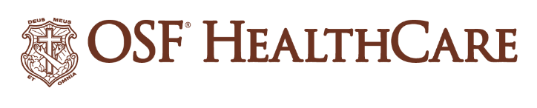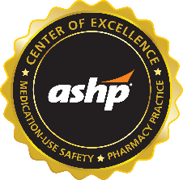

OSF HealthCare pharmacies earn ASHP Center of Excellence designation

FOR IMMEDIATE RELEASE
Contact: Shelli Dankoff, Manager, Media Relations & Multimedia Services | shelli.j.dankoff@osfhealthcare.org
(May 14, 2025 |PEORIA, Illinois) – OSF HealthCare has become the first mid-to-large size integrated health system in the United States to earn the prestigious ASHP (American Society of Health-System Pharmacists) Certified Center of Excellence™ in Medication-Use Safety and Pharmacy Practice designation.

The certification process is used by health care organizations in the United States to accurately assess their level of performance in relation to established standards and to implement ways to continuously improve. Pharmacies which achieve this ASHP certification demonstrate the highest levels of pharmacy practice, medication safety, and pharmacy patient care services.

OSF earned the designation for 16 hospitals, six community pharmacies, one specialty pharmacy, one home infusion pharmacy, one ePharmacy, and the integrated distribution center.

“OSF Healthcare Pharmacy Services has worked over the last eight years to innovate and elevate pharmacy care to deliver consistent safe, quality, cost-effective care so that all the communities we serve have access to the same standard of care. We tested our model and outcomes with external feedback from the single national certification body for such rigor. Delivery of high-quality care to our patients is a strong motivator for our OSF pharmacy Mission Partners (employees),” said Sandra Salverson, Senior Vice President Pharmacy Services, OSF HealthCare. “While it is common for tertiary academic medical centers to achieve such certification, it is important to additionally demonstrate and validate excellence can be delivered in rural communities, community hospitals, and through novel models of care delivery such as our ePharmacy. This certification confirms the quality OSF pharmacy services offer and provides external peer feedback for on-going professional growth and innovation. All of this aligns with the Mission and values of OSF HealthCare.”

Becoming an ASHP Certified Center of Excellence™ in Medication-Use Safety and Pharmacy Practice allows organizations to differentiate themselves from others and demonstrates the following:
• Reflects use of contemporary best practices for hospital and health-system pharmacy practice
• Demonstrates commitment to excellence, continuous quality improvement, and practice advancement
• Provides evidence of current, innovative pharmacy services leading to high quality care and improved patient
outcomes
• Validates pharmacy services externally through rigorous certification process
• Enhances credibility and value of pharmacy services to physicians, nurses, healthcare leaders, policy makers

- 30 -

OSF HealthCare is an integrated health system founded by The Sisters of the Third Order of St. Francis. Headquartered in Peoria, Illinois, OSF HealthCare has 17 hospitals – 11 acute care, five critical access, one continuing care – with 2,305 licensed beds throughout Illinois and Michigan. OSF employs more than 26,000 Mission Partners across 160+ locations and includes OSF OnCall, the digital health operating entity which offers a hospital-at-home. Advances in health care transformation take place through OSF Innovation and OSF Children’s Hospital of Illinois, the third largest pediatric hospital in Illinois, cares for our smallest patients. In addition, OSF has two colleges of nursing; operates OSF Home Care Services, an extensive network of home health and hospice services; owns Pointcore, Inc., comprised of health care-related businesses; OSF HealthCare Foundation, the philanthropic arm for the organization; and OSF Ventures, which provides investment capital for promising health care innovation startups. OSF HealthCare has been recognized by Fortune as one of the most innovative companies in the country. More at osfhealthcare.org.

