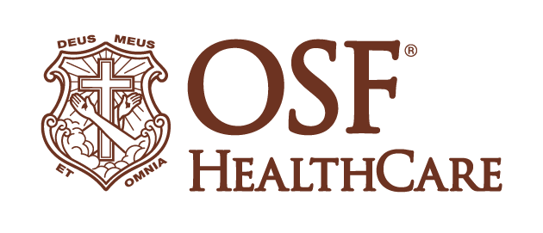
OSF HealthCare partners with Elemeno Health to pilot point-of-care communication and training innovation for frontline nurses
Contacts: Colleen Reynolds | Media Relations Coordinator, OSF HealthCare | cell: (309) 825-7255
Veena Kumar | Product Marketing, Elemeno Health| (510) 517-7851
(January 31, 2022/PEORIA, ILLINOIS and OAKLAND, Calif.) – Elemeno Health, the developer of a proprietary cloud-based solution for frontline health care teams, and OSF HealthCare, one of the largest health systems in Illinois, today announced a partnership to initiate a pilot using a customizable, just-in-time best practices app for nurses.
The Peoria, Illinois-based integrated health system operates 15 hospitals in Illinois and Michigan with a robust innovation division. Cross-functional collaboration is an organizational priority and OSF Innovation regularly seeks to understand the pain points and experiences of our frontline care givers, including nurses who care deeply about quality patient outcomes and providing the best patient experience. By understanding the voice of our frontline caregivers and partnering with them, OSF Innovation is able to serve the Ministry through identification and implementation of solutions that support them in the work they do each day and create a better Mission Partner (employee) experience.
With emerging variants, vaccine approvals, and shifting guidance from the Centers for Disease Control and Prevention during the COVID-19 pandemic, it became clear that nurses busy caring for patients needed an easy way to ensure they had the latest information. OSF Innovation saw the potential in Elemeno as a tool to provide OSF nurses with point of care education that is easy to access, relevant and timely, and worked closely with nursing leadership to help define potential use cases and value. Elemeno’s mobile-friendly platform allows for real-time updates on changes in practice, implementation of new treatments, products, even specific notifications based on information learned during team huddles.
Elemeno will be piloted in several specific departments within the OSF HealthCare system, including at OSF HealthCare Saint Francis Medical Center, a Level 1 trauma center in Peoria, with a goal of full implementation within hospitals and clinics.
“With quickly shifting resources during the COVID-19 pandemic, this type of communication tool can assist nurses on individuals floors, within a department or within the entire hospital, to help key players on care teams to be prepared for day to day changes,” said Lori Wiegand, chief nursing officer for OSF HealthCare. “OSF Innovation and its performance improvement teams consistently help advance novel approaches to problems, including efforts to pilot leading-edge technology to provide the highest quality care possible to our patients.”
“Elemeno is designed to meet nurses where they are, so they have access to easy-to-digest content, including how-to videos and interactive decision guides, in a way that supports every type of learner,” said Jill Williamson, director of Education at OSF HealthCare. “Site-specific, data-informed details can be shared, along with evidence-based standards, policies and procedures.”
With many hospital systems, including OSF, having to hire travel nurses to supplement care during COVID-19 surges, the Elemeno platform helps streamline onboarding and training to drive system-wide consistency with workflows, policies and procedures. The easy-to-use platform can reinforce a safety-first mentality that is critically important as clinicians manage the heavy burden of caring for patients, many of whom require complex care if they are hospitalized with COVID-19.
“We need to make nurses’ lives simpler,” noted Arup Roy-Burman, CEO and co-founder of Elemeno Health. “As a playbook in your pocket, Elemeno equips frontline nursing staff with the bite-sized information they need to easily deliver consistent and safe care to every patient.”
Initial success will be measured through metrics around engagement and adoption, as well as feedback from users.
# # #
OSF HealthCare is an integrated health system owned and operated by The Sisters of the Third Order of St. Francis, headquartered in Peoria, Illinois. OSF HealthCare employs nearly 24,000 Mission Partners in 150 locations, including 15 hospitals – 10 acute care, five critical access – with 2,089 licensed beds, and two colleges of nursing throughout Illinois and Michigan. The OSF HealthCare physician network employs more than 1,500 primary care, specialist and advanced practice providers. OSF HealthCare, through OSF Home Care Services, operates an extensive network of home health and hospice services. It also owns Pointcore, Inc., comprised of health care-related businesses; OSF HealthCare Foundation, the philanthropic arm for the organization; and OSF Ventures, which provides investment capital for promising health care innovation startups. More at osfhealthcare.org.
OSF Innovation, launched in 2016, is the umbrella initiative for the planning, structure, goals, and services OSF HealthCare uses to innovate for the improvement and transformation of health care.
More information at osfinnovation.org.
Elemeno Health provides a cloud solution that helps health care systems empower frontline staff with hyper-localized bite-size support (how-to video, interactive decision guides, latest updates) specific to each team’s workflows and resources. As a “playbook in your pocket,” Elemeno makes best practices accessible and consumable just-in-time, on any device, driving the consistent delivery of high-quality care. Elemeno is deployed in major health systems nationally, including UCSF Health, El Camino Health, LCMC Health, and RWJBarnabas Health. Elemeno is winner of the American College of Emergency Physicians’ 2021 Emergency Medicine Innovator of the Year. Learn more at elemenohealth.com.

