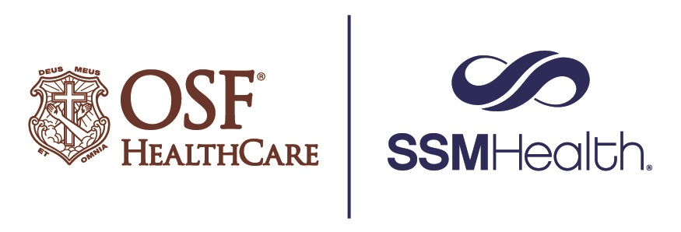

OSF HealthCare and SSM Health collaborate to bring enhanced services to Alton

FOR IMMEDIATE RELEASE
Contact: Tim Ditman, Media Relations Coordinator, OSF HealthCare | (309) 838-9664
Kanna Rook, Communications Manager, SSM Health | (636) 866-4884

(April 11, 2022 | ALTON, Illinois) – Patients of OSF HealthCare Saint Anthony’s Health Center in the greater Riverbend community will soon have access to a comprehensive network of specialty and subspecialty physicians through the formation of a new strategic affiliation with SSM Health, a Catholic health care system based in the St. Louis area.

The strategic affiliation will better serve patients in the community by bringing exceptional medical and surgical specialties closer to home. This collaboration between OSF Saint Anthony’s and SSM Health combines a commitment to exceptional care with an expanded network of expert specialty and subspecialty physicians to provide a comprehensive network.

One of the first collaborations is the addition of Sridhar Kumar, MD, a SLUCare cardiologist at SSM Health Saint Louis University Hospital, who will become chief of Cardiology Services at OSF Saint Anthony’s. Under Dr. Kumar’s leadership, patients will receive the highest-quality of innovative care and expertise needed to treat heart diseases and cardiovascular conditions all close to home.
This new affiliation provides patients of OSF Saint Anthony’s who require a higher level of care access to SSM Health medical experts and state of the art facilities with the latest technologies and procedures offered in the St. Louis region.
“Hospital and healthcare providers can no longer operate in silos and must be willing to embrace meaningful collaboration that will result in availability of high quality, sustainable health care across their communities,” said OSF Saint Anthony’s President Jerry Rumph. “Dr. Kumar will oversee a wide range of cardiac interventions, including state-of-the-art treatments, invasive and non-invasive testing, and medical management of heart failure and vascular diseases. He also brings unique experience with adult congenital heart conditions and has spent decades performing interventional cardiac procedures.”

Jeremy Fotheringham, president of SSM Health in St. Louis and Academics, said, “SSM Health has a 150-year history of providing exceptional health care to the community. We’re proud to partner with OSF Saint Anthony’s allowing for even greater access to high-level cardiac care in the Alton community.”

OSF Saint Anthony’s and SSM Health are excited about and committed to the new affiliation and are currently developing additional opportunities to bring more medical specialties to the greater Riverbend community to enhance and improve the health and wellness of residents.

# # #

About OSF HealthCare Saint Anthony’s Health Center: A 49-bed Rural Health designated acute care hospital in Alton, Illinois, OSF Saint Anthony’s serves the residents of Madison, Jersey and Macoupin counties. It is home to OSF Moeller Cancer Center, which provides the latest diagnostic tools and treatment for patients in a relaxing environment. OSF Saint Anthony’s also provides 24-hour access to a physician-staffed emergency department, in addition to cardiovascular, neurology, pulmonology, surgical, rehabilitation services and more. OSF Saint Anthony’s is fully accredited by the Joint Commission for Healthcare Facilities, American College of Surgeons’ Commission on Cancer, American College of Radiology, Leap Frog “A” Safety Rating of Hospitals, CMS Four-Star Rating, American Heart Association, IDPH and TJC Primary Stroke Center. OSF Saint Anthony’s is part of OSF HealthCare – an integrated health system with 15 hospitals in Illinois and Michigan and robust Innovation and Digital Health divisions that provide access to specialty care and remote monitoring, helping people receive the care they need close to home. OSF HealthCare is operated by The Sisters of the Third Order of Saint Francis.

About SSM Health: SSM Health is a Catholic, not-for-profit health system serving the comprehensive health needs of communities across the Midwest through a robust and fully integrated health care delivery system. The organization’s nearly 40,000 employees and more than 11,000 providers are committed to providing exceptional health care services and revealing God’s healing presence to everyone they serve. SSM Health in St. Louis operates eight hospitals, six urgent care locations, four SSM Health Express Clinics and more than 40 medical offices in the area. For more information, visit us at ssmhealth.com or find us on Facebook and Twitter.

