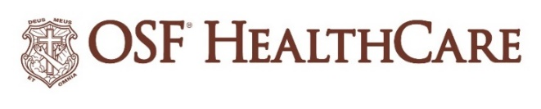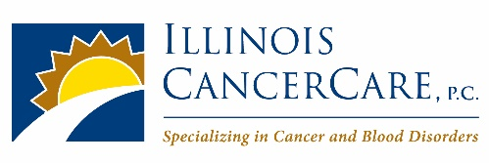
OSF HealthCare & Illinois CancerCare announce collaboration to further
cancer care throughout Illinois

FOR IMMEDIATE RELEASE
Contact: Shelli Dankoff, Media Relations Supervisor - OSF HealthCare (309) 634-8583
Alli Turner, Marketing Communication Manager – Illinois CancerCare (312) 206-8704
(July 21, 2022 |PEORIA, Illinois) – OSF HealthCare and Illinois CancerCare are pleased to announce an enhanced collaboration, allowing both entities to better deliver world-class, personalized and comprehensive cancer care while advancing research and cancer technology capabilities for residents throughout the state of Illinois.
OSF marked a new era in August of 2021 with the groundbreaking for the OSF HealthCare Cancer Institute, a 180,000-square-foot building on the campus of OSF HealthCare Saint Francis Medical Center in downtown Peoria. It is expected to open to patients in early 2024.
The OSF Cancer Institute will include Illinois CancerCare’s 15th clinic location. Illinois CancerCare looks forward to being a premier provider of medical oncology services in the OSF Cancer Institute and shared regional satellite clinics, including the new cancer center through OSF Saint Joseph Medical Center for the Bloomington-Normal community. Communities surrounding central Illinois including Pontiac, Ottawa, Princeton, Kewanee, Galesburg and Monmouth will be further developed as part of a strong cancer network between OSF and Illinois CancerCare, ensuring patients have access to all the coordinated care and services that are provided in larger markets.
“We are excited about our growing collaboration and continued commitment to delivering world-class patient care and technology for the Peoria area and beyond,” said Madhuri Bajaj, M.D., Medical Oncology/Hematology, Internal Medicine, Illinois CancerCare. “As trusted leaders in cancer care, Illinois CancerCare and OSF HealthCare are working together to bolster clinical and research capabilities, collaborate on personal and comprehensive cancer care and provide even more convenience for all Illinois communities.
As part of the collaboration, Dr. Bajaj will serve as medical director for the medical oncology/hematology program between OSF and Illinois CancerCare.
Doctors and other providers from Illinois CancerCare and OSF representing different specialties already meet regularly to discuss cases and share knowledge. Working together, this multi-disciplinary approach to cancer care will be further developed and expanded. The two will expand tumor boards that offer collaboration via state-of-the-art teleconferencing including multi-disciplinary education and treatment plans with an assigned cancer navigator for all patients.
“OSF HealthCare’s mission to serve with the greatest care and love aligns well with Illinois CancerCare’s patient-first focus,” added Michael Cruz, M.D., Chief Operating Officer, OSF HealthCare. “As two independent entities who have long been committed to helping patients through their cancer journeys, we are excited about elevating the cancer care experience of our mutual patients in the region.”
Clinical Trial Research is a critical focus of both organizations. OSF and Illinois CancerCare will work to expand their collective research offerings with each other to bring even more trial options to patients.
Illinois CancerCare will continue to be an independent practice providing medical oncology and hematology services to OSF HealthCare patients in Peoria as well as in mutual regional satellites.
The expanded affiliation between OSF HealthCare and Illinois CancerCare is effective immediately.
- 30 -

OSF HealthCare is an integrated health system owned and operated by The Sisters of the Third Order of St. Francis, headquartered in Peoria, Illinois. OSF HealthCare employs nearly 24,000 Mission Partners in 150 locations, including 15 hospitals – ten acute care, five critical access – with 2,089 licensed beds, and two colleges of nursing throughout Illinois and Michigan. The OSF HealthCare physician network employs more than 1,500 primary care, specialist and advanced practice providers. OSF HealthCare, through OSF Home Care Services, operates an extensive network of home health and hospice services. It also owns Pointcore, Inc., comprised of health care-related businesses; OSF HealthCare Foundation, the philanthropic arm for the organization; and OSF Ventures, which provides investment capital for promising health care innovation startups. More at www.osfhealthcare.org.

Illinois CancerCare is one of the largest practices in the state of Illinois that treats patients with cancer and blood diseases. It provides state of the art treatments to its patients against these complex diseases by staying at the leading edge of clinical research. Illinois CancerCare is central Illinois’ largest network of cancer care specialists with approximately 100 open clinical cancer research trials being conducted at any given time. The group has been recognized by the Quality Oncology Practice Initiative (QOPI®) Certification Program for outpatient hematology-oncology practices that meet the highest national standards for quality cancer care. Illinois CancerCare has 18 physicians, over 30 APN’s and more than 500 staff members. Illinois CancerCare serves patients at 15 clinic locations throughout central and western Illinois including Bloomington/Normal, Canton, Carthage, Dixon, Eureka, Galesburg, Kewanee, Macomb, Ottawa, Pekin, Peoria, Peru, Princeton and Washington. More at www.illinoiscancercare.com

