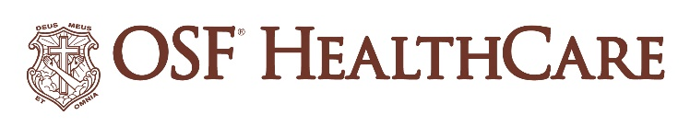

OSF HealthCare names new central region CEO

For immediate release
Contact: Shelli Dankoff | Media Relations Supervisor, OSF HealthCare | (309) 655-3897

(Peoria, IL | August 5, 2022) – OSF HealthCare Saint Francis Medical Center President Bob Anderson has been named chief executive officer for OSF HealthCare’s central region. He will continue to serve as president of OSF Saint Francis until a replacement has been hired.
He replaces Mike Cruz, M.D. as central region CEO after Dr. Cruz was named Chief Operating Officer for the 15-hospital system.
In his new role, which is effective September 1, Anderson will serve as the operational leader for OSF’s central region which includes OSF Saint Francis, OSF Children’s Hospital of Illinois in the Peoria area, OSF Aviation, and the broader geographic area to the north and south of the Peoria tri-county area.
Anderson will be responsible for ensuring that clinical and administrative services are organized to meet the needs of those served by OSF HealthCare, as well as the market. Along with the other regional CEOs, Anderson will also be accountable for the delivery of improved health care to OSF patients and the performance of OSF Mission Partners (employees) across the OSF Ministry.
Anderson began his career at OSF HealthCare in 1981 as a medical technologist in the laboratory services department. He went on to serve as senior vice president and chief operating officer at OSF Saint Francis before being named president in 2017. Since then Anderson has overseen a number of initiatives to benefit care for the community including the OSF HealthCare Cancer Institute, set to open in 2024 on the OSF Saint Francis campus.
Anderson earned his Bachelor of Science in Medical Technology from Eureka College and earned a Master of Science degree in Health Services Administration from the University of St. Francis in Joliet. He is a Fellow of the American College of Healthcare Executives.

# # #

About OSF HealthCare:
OSF HealthCare is an integrated health system owned and operated by The Sisters of the Third Order of St. Francis, headquartered in Peoria, Illinois. OSF HealthCare employs nearly 24,000 Mission Partners (employees) in 150 locations, including 15 hospitals – ten acute care, five critical access – with 2,089 licensed beds, and two colleges of nursing throughout Illinois and Michigan. The OSF HealthCare physician network employs more than 1,500 primary care, specialist and advanced practice providers. Learn more at https://www.osfhealthcare.org.

