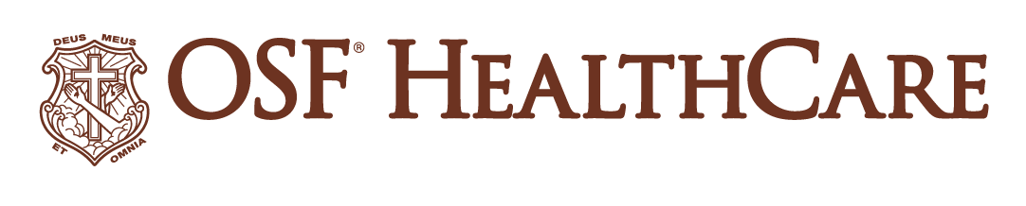
Proton therapy cyclotron arrives at OSF HealthCare Cancer Institute

For Immediate Release
Contact: Shelli Dankoff, Media Relations Supervisor (309) 634-8583
(Oct. 20, 2022 | Peoria, Ill.) – OSF HealthCare is marking the next phase of construction for the OSF HealthCare Cancer Institute on the campus of OSF Saint Francis Medical Center in Peoria with the arrival of the particle accelerator that will produce proton therapy treatments.

The Varian ProBeam® 360° System was installed after being transported by trailer from Maryland, where it made port after sailing via ship from the manufacturing plant in Germany. The specially designed, 210-foot long trailer weighed 200 tons with the cyclotron accounting for 100 tons of that.

Proton therapy is an advanced form of cancer care. Protons are accelerated to about two-thirds the speed of light, or more than 100,000 miles per second, to destroy cancer cells, while minimizing exposure to nearby healthy tissues.

The Varian ProBeam® 360° system features the most powerful particle accelerator available to treat cancer, a 360-degree gantry for clinical efficiency, and cone-beam CT imaging, and high-definition pencil-beam scanning for exceptional precision. The system can also provide clinicians a viable path to potential next-generation treatments such as FLASH therapy.

“Bringing proton therapy to central Illinois is going to be a game changer,” said Bob Anderson, central region CEO for OSF HealthCare, which includes the Peoria area. “It will allow us to provide a totally unique type of radiation therapy to patients in Peoria, where people used to have to travel to Chicago or St. Louis to receive that same care.”

OSF HealthCare is committed to making Peoria a premier destination for world-class cancer care. As a regional destination center with the latest technology, one of the hallmarks of the OSF Cancer Institute will be proton beam therapy, which will be just the second center in Illinois, and one of only 32 in North America.

“The work on the Cancer Institute began over four years ago and the centerpiece was always proton therapy. And to see that coming to fruition with the delivery of the unit is extremely exciting. Now, we know it will take a whole year to set up and get it ready to go, but the arrival is a huge milestone for this project” Anderson added.

After completing the trip, the four separate parts of the particle accelerator were carefully lowered into a vault below ground that features a concrete base with pylons drilled 60 feet into the ground supporting concrete walls six to 12 feet-thick, with a total of 3,500+ cubic yards of concrete surrounding the cyclotron.

“OSF HealthCare has always been on the pioneering edge of taking care of cancer patients and doing the right thing,” said John Kowal, President of Varian Oncology Systems for the Americas. “This is just the next step, literally of bringing proton therapy to Peoria and the rest of Illinois, all parts that OSF HealthCare takes care of. This matches Varian’s vision of trying to create a world without fear of cancer. And the delivery of this technology is right on par with executing on that.”

Another special component to the particle accelerators produced by Varian Medical is that each gets a name before it leaves the factory. OSF HealthCare named its Marie after Sister Francis Marie, who started the concept of a ministry-wide oncology program for OSF HealthCare, and also for Marie Curie, a pioneer in the field of radioactivity and the first woman to win a Nobel Prize.

In addition to proton beam and brachytherapy, the OSF Cancer Institute will feature an infusion center, patient education and support spaces, and a full range of cancer-related services.

The first treatments at the OSF Cancer Institute are expected to take place by early 2024.

