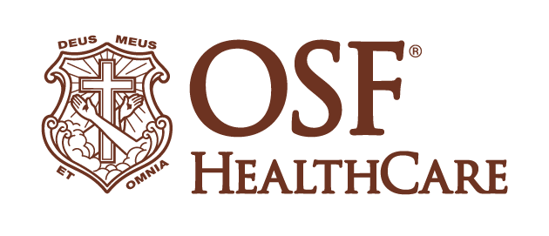
OSF HealthCare and UIC grants fund projects to promote health equity
Community Health Advocacy program creating fast solutions to improve access, communication & education
For immediate release
Contacts: Colleen Reynolds | Media Relations Coordinator – OSF HealthCare | (309) 825-7255
Elaine Harvey | Assistant Director of Innovation and Outreach -UIC
(January 26, 2023/PEORIA, Ill.) – Peoria, Illinois-based OSF HealthCare and the University of Illinois Chicago (UIC) are awarding nearly $1 million in grants as part of its Community Health Advocacy (CHA) program to address health and wellness challenges in urban communities.
The latest round of grants will fund 10 projects, leveraging OSF Innovation expertise and faculty from 16 colleges and health sciences at UIC. Grant recipients are expected to create solutions that can be deployed quickly, within four to six weeks.
The projects will examine patient experience for at-risk individuals who use the emergency department at OSF HealthCare Little Company of Mary Medical Center in south suburban Evergreen Park, explore ways to build a pipeline for allied health and first-line health care providers, develop a plant-based diet that would appeal to Black men at risk for prostate cancer and expand communication tools for exploring social needs for patients, particularly for non-English-speaking individuals and those with special needs.
Other projects will launch a pilot in homeless shelters, use an artificial intelligence (AI) -based tool to check for diabetes-related vision problems and develop AI curriculum for medical students. Another will focus on creating the best strategies to communicate the risks of cannabis consumption on women of child-bearing age before, during and after pregnancy.
“Given the massive workforce shortages across the industry, our focus is on using technology and evidence-based approaches for strategies to serve our patients most effectively and solve some of the biggest challenges that prevent individuals from achieving better health and wellness,” says
Dr. John Vozenilek, chief medical officer for Innovation & Digital Health at OSF HealthCare. “We’re also attempting to make sure we reach all populations that deserve a holistic approach to improving their health and their experience with health care.”
TJ Augustine, vice chancellor for Innovation at UIC says, “As Chicago's only public research university, we are uniquely positioned to address a wide range of community health challenges. Having OSF HealthCare as a partner is key to implementing solutions that make an impact. We’re proud that our partnership will yield best practices that help not only UIC and OSF, but that also support community medical providers who serve diverse populations.”
Here is a complete list and description of the projects receiving CHA grants.
Highlight Project: Prenatal Cannabis Exposure: Investigating Reasons and Messaging- With cannabis laws changing at a rapid pace, traditional media and social media are saturated with positive messages about recreational or medicinal use of cannabis, and many people think it is safe because it’s marketed as being “natural.” Dr. William Bond of OSF HealthCare is working with co-lead Erin Berenz, PhD, of the University of Illinois at Chicago on a Community Health Advocacy (CHA) grant to investigate women’s risk perceptions of using cannabis in pregnancy. Read more.
# # #

OSF HealthCare is an integrated health system owned and operated by The Sisters of the Third Order of St. Francis, headquartered in Peoria, Illinois. OSF HealthCare employs nearly 24,000 Mission Partners in 150 locations, including 15 hospitals – ten acute care, five critical access – with 2,098 licensed beds, and two colleges of nursing throughout Illinois and Michigan. The OSF HealthCare physician network employs more than 1,500 primary care, specialist and advanced practice providers. OSF HealthCare, through OSF Home Care Services, operates an extensive network of home health and hospice services. It also owns Pointcore, Inc., comprised of health care-related businesses; OSF HealthCare Foundation, the philanthropic arm for the organization; and OSF Ventures, which provides investment capital for promising health care innovation startups. More at www.osfhealthcare.org/.
Jump Simulation, a part of OSF Innovation, is a collaboration between University of Illinois College of Medicine Peoria and OSF HealthCare. The center replicates a variety of patient care settings to ensure novice and seasoned clinicians can practice handling medical situations in a life-like environment. Boasting six floors and 168,000 square feet, the center is one of the largest of its kind and provides space for conferences, anatomic training, virtual reality and innovation. For more information, visit www.jumpsimulation.org/.
OSF Innovation, launched in 2016, is a multidisciplinary innovation center focused on internal and external innovation to solve the largest health care challenges. More at www.osfinnovation.org.
University of Illinois Chicago (UIC) is a hub of innovation and cutting-edge research with a commitment to discovery and solving real-world problems. UIC is the city’s largest university and only public research institution with 16 colleges and more than 33,000 students. UIC is recognized as one of the most ethnically rich and culturally diverse campuses in the nation, a leader in providing access to underrepresented students. With one of the largest colleges of medicine in the nation, and colleges of dentistry, pharmacy, public health, nursing, social work, and applied health sciences, UIC is also the state’s principal educator of health professionals and a major healthcare provider to underserved communities. More at https://www.uic.edu/.

