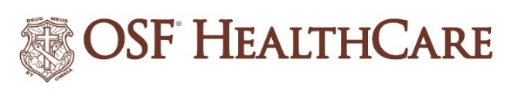

OSF HealthCare names new president of
OSF HealthCare Foundation

FOR IMMEDIATE RELEASE
Contact: Shelli Dankoff, Media Relations & Multimedia Services Manager | shelli.j.dankoff@osfhealthcare.org

(June 30, 2026 | PEORIA, Illinois) – Jacque Schweighart, M.Ed., has accepted the position of chief development officer and president of OSF HealthCare Foundation.
Schweighart will be accountable for defining and driving a unified philanthropic strategy that aligns donor priorities with the Mission of OSF HealthCare and strategic focus areas. She will lead an integrated fundraising enterprise across all giving channels, accelerate endowment growth through strategic partnerships and serve as the Foundation’s chief ambassador to internal and external stakeholders.
Schweighart most recently served as senior vice president of Central Development Services for the University of Illinois Foundation. She has led and worked in nearly all areas of development and fundraising, from major, principal and planned giving programs, to annual giving and volunteer engagement programs and has built donor recognition, stewardship and campaign infrastructure.
Schweighart earned her Bachelor of Science in advertising from the University of Illinois at Urbana-Champaign, where she also earned a Master of Education in educational organization and leadership. Her new position is effective August 3.
- 30 -
OSF HealthCare is an integrated health system founded by The Sisters of the Third Order of St. Francis and headquartered in Peoria, Illinois. The system includes 18 inpatient facilities encompassing 16 licensed hospitals, two of which operate dual campuses in separate communities. Among these hospitals, 10 are acute care facilities, five are critical access hospitals and one is a continuing care facility. OSF has 2,141 licensed beds throughout Illinois and Michigan and employs more than 27,000 Mission Partners across 170+ locations. These include OSF HealthCare Children’s Hospital of Illinois, the third largest pediatric hospital in the state, and OSF OnCall, its digital health operating entity that offers hospital-at-home care. In addition, OSF operates two colleges of nursing; OSF Home Care Services, an extensive network of home health and hospice services; Pointcore, Inc., which is composed of health care-related businesses; and OSF HealthCare Foundation, the philanthropic arm of the organization. Advances in health care transformation take place through OSF Innovation as well as OSF Ventures, which provides investment capital for promising health care innovation startups. OSF HealthCare has been recognized by Fortune as one of the most innovative companies in the country and by Forbes as one of America’s Best Employers for Healthcare Professionals. Learn more at osfhealthcare.org.

