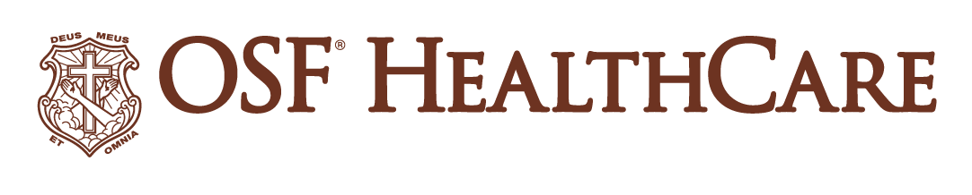
OSF HealthCare expanding surgery offerings in Champaign area

FOR IMMEDIATE RELEASE
Contact: Tim Ditman, OSF HealthCare Media Relations Coordinator | (309) 838-9664

(May 5, 2023 | URBANA, Illinois) – OSF HealthCare is investing in an ambulatory surgical center in Champaign, Illinois, as part of its strategic growth plan in the community.
The joint venture will see OSF partner with Sid Rohrscheib, MD, an independent general surgeon who currently performs surgeries at OSF HealthCare Heart of Mary Medical Center in Urbana as well as various other locations. OSF will own a majority interest of Olympian Surgical Suites, while Dr. Rohrscheib will be a minority owner.
The facility is located at 1002 Interstate Drive in Champaign and is owned by another entity. OSF Heart of Mary will be seeking the appropriate state and regulatory approvals to pursue this joint venture.
“We are committed to the Champaign-Urbana community, and this is one example of how we are investing in new care pathways for residents in Champaign County,” said J.T. Barnhart, president of OSF Heart of Mary. “More and more, insurance companies nationwide are starting to dictate that certain procedures, such as colonoscopies, cannot be done inside hospitals. So for the long-term viability of the OSF HealthCare community presence and ensuring our patients can receive the care they need, we wanted to make sure our patients have the option to stay within OSF HealthCare for their care.”
“We anticipate no disruption to patient care at this point,” Barnhart added. “Once the dust settles, we will reevaluate any opportunities to relocate outpatient services to the new building. We also look forward to this center providing additional opportunities to partner with physicians in the community.”

# # #

OSF HealthCare is an integrated health system owned and operated by The Sisters of the Third Order of St. Francis, headquartered in Peoria, Illinois. OSF HealthCare employs nearly 23,000 Mission Partners in 157 locations, including 15 hospitals – 10 acute care, five critical access – with 2,084 licensed acute care beds, 45 urgent care locations and two colleges of nursing throughout Illinois and Michigan. The OSF HealthCare physician network employs more than 1,900 primary care, specialty and advanced practice providers. OSF HealthCare, through OSF Home Care Services, operates an extensive network of home health and hospice services. It also owns Pointcore, Inc., composed of health care-related businesses; OSF HealthCare Foundation, the philanthropic arm of the organization; and OSF Ventures, which provides investment capital for promising health care innovation startups. The Ministry OSF HealthCare Services office in Peoria provides corporate management services, as well as direction, consultation and assistance to the administration of the health care facilities. More at osfhealthcare.org.
Pronunciations for broadcast media:
Rohrscheib: ROAR-shybe

