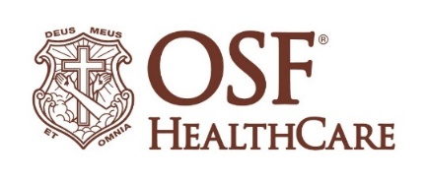
OSF HealthCare breaks ground on Brimfield medical office building

FOR IMMEDIATE RELEASE
Contact: Beau Ebenezer | Public Relations and Communications Coordinator | Beau.R.Ebenezer@osfhealthcare.org
(February 18, 2026 | Peoria, Illinois) – OSF HealthCare leaders, Foundation representatives and community stakeholders gathered Wednesday afternoon to celebrate the groundbreaking of the OSF HealthCare Brimfield medical office building.

The ceremony marked the start of construction on a new facility at the intersection of Route 150 and Maher Road in Brimfield. The new building will replace the current clinic located at 111 E. Knoxville St. and is designed to expand access to primary care services in the growing community.

The new medical office building reflects OSF HealthCare’s continued commitment to meeting patients closer to home and investing in the long-term health of the communities it serves.

“This groundbreaking represents more than a new building. It represents continued investment in the people and families of Brimfield,” said Robert Bevill, MD, OSF Medical Group - Primary Care in Brimfield. “We are committed to providing convenient, high-quality care and strengthening access to primary care services for our community.”

Construction is expected to continue throughout 2026. Photos from the groundbreaking ceremony can be found on the OSF Newsroom.

# # #

OSF HealthCare is an integrated health system founded by The Sisters of the Third Order of St. Francis and headquartered in Peoria, Illinois. The system includes 18 inpatient facilities encompassing 16 licensed hospitals, two of which operate dual campuses in separate communities. Among these hospitals, 10 are acute care facilities, five are critical access hospitals and one is a continuing care facility. OSF has 2,141 licensed beds throughout Illinois and Michigan and employs more than 27,000 Mission Partners across 170+ locations. These include OSF HealthCare Children’s Hospital of Illinois, the third largest pediatric hospital in the state, and OSF OnCall, its digital health operating entity that offers hospital-at-home care. In addition, OSF operates two colleges of nursing; OSF Home Care Services, an extensive network of home health and hospice services; Pointcore, Inc., which is composed of health care-related businesses; and OSF HealthCare Foundation, the philanthropic arm of the organization. Advances in health care transformation take place through OSF Innovation as well as OSF Ventures, which provides investment capital for promising health care innovation startups. OSF HealthCare has been recognized by Fortune as one of the most innovative companies in the country and by Forbes as one of America’s Best Employers for Healthcare Professionals. Learn more at osfhealthcare.org.

