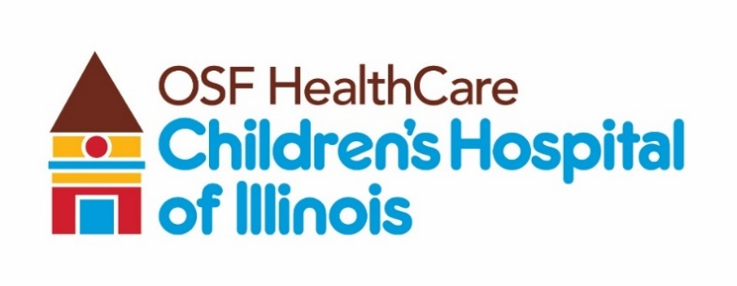
Hematology Oncology Nurses’ Day proclaimed in Peoria

Available for immediate release:
Contact: Beau Ebenezer | Public Relations and Communications Coordinator | Beau.R.Ebenezer@osfhealthcare.org

(September 13, 2024 | Peoria, Illinois) – Peoria Mayor Rita Ali issued a proclamation at OSF HealthCare Children’s Hospital of Illinois on Thursday, Sept. 12, officially recognizing Sept. 8 as Pediatric Hematology Oncology Nurses’ Day in Peoria.

The day, established in 2010 by the Association of Pediatric Hematology/Oncology Nurses (APHON), is celebrated annually on Sept. 8. Children’s Hospital of Illinois, home to a local chapter of APHON, honors its nurses and staff throughout the week. This year, the celebration featured a Harry Potter theme, bringing smiles to patients and visitors alike.

After delivering the proclamation, Mayor Ali toured the Pediatric Hematology Oncology unit and clinic, where she met the dedicated nurses who care for children with cancer and blood disorders.

# # #

About OSF HealthCare Children’s Hospital of Illinois:
Located in Peoria, OSF HealthCare Children’s Hospital of Illinois is the third largest pediatric hospital in Illinois and the most comprehensive hospital for kids downstate. With 136 beds and more than 140 pediatric subspecialists, OSF Children’s Hospital cares for more children in Illinois than any hospital outside of Chicago. Formally established as a pediatric hospital within the walls of OSF HealthCare Saint Francis Medical Center in 1990, OSF Children’s Hospital of Illinois has more than 7,000 inpatient admissions, 75,000 outpatient specialty visits, 2,400 newborn deliveries, and 18,000 emergency department visits each year. Learn more by visiting childrenshospitalofillinois.org.

