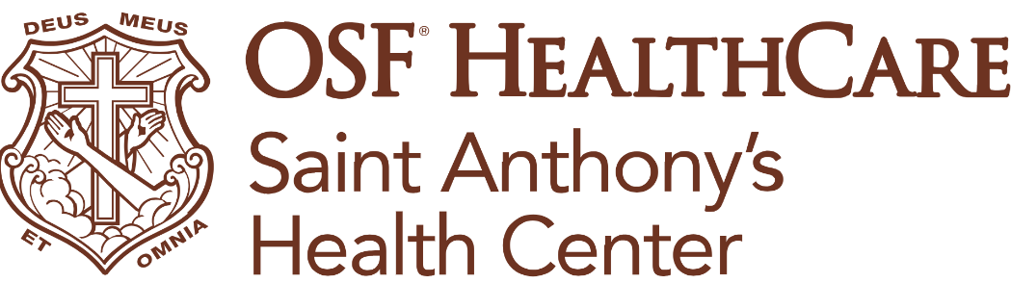
Schepers named permanent president at OSF Saint Anthony’s
FOR IMMEDIATE RELEASE
Contact: Tim Ditman, media relations coordinator | timothy.r.ditman@osfhealthcare.org | (309) 838-9664
NOTE FOR REPORTERS: Photos, b-roll and more for this release are available here.
(May 28, 2026 | Alton, Illinois) – OSF HealthCare has named Lisa Schepers, DNP, as the next permanent president of OSF HealthCare Saint Anthony’s Health Center in Alton, Illinois. Schepers has been interim president since February 2026, when Zach Yoder departed to lead three other hospitals in the OSF Western Region.
As president, Schepers will oversee all operations at OSF Saint Anthony’s, with a focus on strengthening hospital performance, elevating patient experience and ensuring delivery of high-quality, cost-effective care to the communities OSF serves.
“I’m excited to have the opportunity to continue to lead this pillar of the Riverbend community,” Schepers said. “We have made great progress in recent years in delivering safe, quality care, highlighted by our recent fifth straight hospital safety A grade from the Leapfrog Group. But, we are always striving to improve, and I’m looking forward to leading those efforts.”
Schepers earned a Bachelor of Science in nursing from Deaconess College of Nursing in St. Louis, Missouri. She went on to earn a Master of Business Administration from Webster University and most recently achieved her Doctor of Nursing Practice from Chamberlain University.
Prior to serving as interim president at OSF Saint Anthony’s, Schepers was the hospital’s chief nursing officer. Recruitment for that position will begin immediately.
###

About OSF HealthCare Saint Anthony’s Health Center: A 49-bed Rural Health designated acute care hospital in Alton, Illinois, OSF Saint Anthony’s serves the residents of Madison, Jersey and Macoupin counties. It is home to OSF Moeller Cancer Center, which provides the latest diagnostic tools and treatment for patients in a relaxing environment. OSF Saint Anthony’s also provides 24-hour access to a physician-staffed emergency department, in addition to cardiovascular, neurology, pulmonology, surgical, rehabilitation services and more. OSF Saint Anthony’s is fully accredited by the Joint Commission for Healthcare Facilities, American College of Surgeons’ Commission on Cancer, American College of Radiology, American Heart Association, IDPH and TJC Primary Stroke Center. OSF Saint Anthony’s is part of OSF HealthCare – an integrated health system with 18 inpatient facilities in Illinois and Michigan and robust Innovation and Digital Health divisions that provide access to specialty care and remote monitoring, helping people receive the care they need close to home. OSF HealthCare is operated by The Sisters of the Third Order of Saint Francis.
OSF HealthCare is an integrated health system founded by The Sisters of the Third Order of St. Francis and headquartered in Peoria, Illinois. The system includes 18 inpatient facilities encompassing 16 licensed hospitals, two of which operate dual campuses in separate communities. Among these hospitals, 10 are acute care facilities, five are critical access hospitals and one is a continuing care facility. OSF has 2,141 licensed beds throughout Illinois and Michigan and employs more than 27,000 Mission Partners across 170+ locations. These include OSF HealthCare Children’s Hospital of Illinois, the third largest pediatric hospital in the state, and OSF OnCall, its digital health operating entity that offers hospital-at-home care. In addition, OSF operates two colleges of nursing; OSF Home Care Services, an extensive network of home health and hospice services; Pointcore, Inc., which is composed of health care-related businesses; and OSF HealthCare Foundation, the philanthropic arm of the organization. Advances in health care transformation take place through OSF Innovation as well as OSF Ventures, which provides investment capital for promising health care innovation startups. OSF HealthCare has been recognized by Fortune as one of the most innovative companies in the country and by Forbes as one of America’s Best Employers for Healthcare Professionals. Learn more at osfhealthcare.org.
Pronunciations:
Schepers: SHEP-ers

