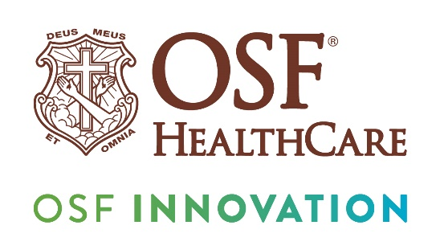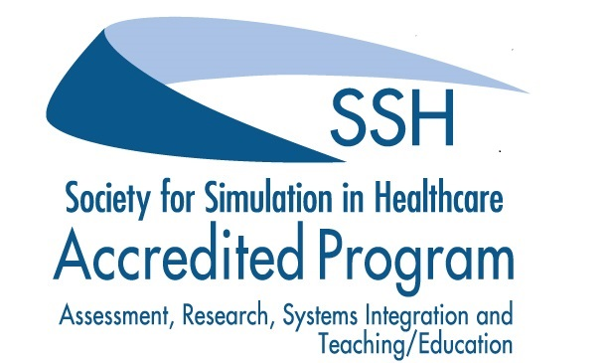
Jump Simulation recognized as a simulation & education leader
For Immediate Release
Contact: Colleen Reynolds | Media Relations Coordinator – OSF HealthCare | (309) 825-7255
(January 9, 2025| PEORIA, Illinois) – Jump Simulation, a part of OSF Innovation and among the largest purpose-built simulation and health care engineering centers in the world, recently received a five-year reaccreditation by the Society for Simulation in Healthcare (SSH). SSH is an international organization that seeks to improve performance and reduce errors in patient care through the use of simulation. It is also the world’s largest health care simulation accrediting body.
The designation comes after an application process that included a visit to the 67,000 square foot Jump Trading Simulation & Education Center in Peoria, Illinois, which opened in 2013. The re-accreditation covers the areas of assessment, research, teaching/education and systems integration.
In their final report, reviewers noted several strengths of the Jump Simulation program:
• The whole organization is built around innovation and integration, co-located with performance improvement, data analytics and other resources.
• Strong organizational buy-in
• Exemplary OSF STEAM program
“The Jump Trading Simulation & Education Center's STEAM (Science, Technology, Engineering, Art and Math) programs cater to a diverse range of students, including college pre-medical students, middle and high school students, at-risk youth, young learners nationwide through remote learning, community and youth organizations, and undergraduate and graduate students from various majors.” The report continues, “These programs aim to inspire interest in health care and STEM fields by offering hands-on, immersive learning experiences designed to equip participants with valuable skills and knowledge for future success in technologically demanding careers.”
The accreditation indicates the Jump Simulation program has served as a resource for quality improvement, patient safety, risk management and related groups, contributing to the enhancement of health care systems which have used its programs and facilities.
“We are proud of the impact the Jump Simulation program is having on transforming health care and this latest recognition speaks to our impact,” says John Vozenilek, MD, chief medical officer, Innovation & Digital Health at OSF HealthCare. “In addition to simulation and education, our program includes valuable research with world-class labs and funding through Jump ARCHES (Applied Research for Community Health through Engineering and Simulation), a grant program that has provided $11.4 million for 168 research projects, 61 of which are ongoing.”
Clinicians, scientists, and engineers are encouraged to collaborate in the development of new ways to solve the most pressing problems in health care. This work is funded through competitive grants sponsored by four Jump-university partnerships. Besides the ARCHES program Jump collaborates with three other Illinois universities, including University of Illinois-Chicago (Community Health Advocacy); Illinois State University (Connected Communities Initiative); and Bradley University (Innovation for Health).
.
Other related facts:
- 22,730 learners were instructed in FY24 through 2,031 different events
- 348 simulations used 56 standardized participants who are highly trained individuals who portray characteristics of a patient, family member or clinical team member
- Jump Trading Simulation & Education Center has been selected to host Society for Simulation in Healthcare SimOps 2025 Conference in July of 2025
# # #
OSF HealthCare is an integrated health system founded by The Sisters of the Third Order of St. Francis. Headquartered in Peoria, Illinois, OSF HealthCare has 17 hospitals – 11 acute care, five critical access, one continuing care – with 2,305 licensed beds throughout Illinois and Michigan. OSF employs more than 26,000 Mission Partners across 160+ locations and includes OSF OnCall, the digital health operating entity which offers a hospital-at-home. Advances in health care transformation take place through OSF Innovation and OSF Children’s Hospital of Illinois, the third largest pediatric hospital in Illinois, cares for our smallest patients. In addition, OSF has two colleges of nursing; operates OSF Home Care Services, an extensive network of home health and hospice services; owns Pointcore, Inc., comprised of health care-related businesses; OSF HealthCare Foundation, the philanthropic arm for the organization; and OSF Ventures, which provides investment capital for promising health care innovation startups. OSF HealthCare has been recognized by Fortune as one of the most innovative companies in the country. More at osfhealthcare.org.
OSF Innovation is a collaborative network of different disciplines that designs bold, strategic solutions to advance the future of health care. Learn more at osfinnovation.org.

