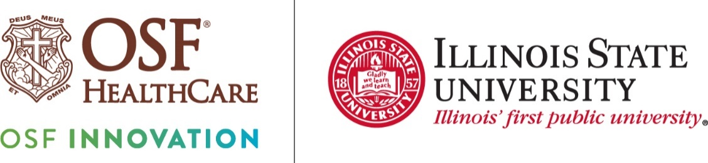
OSF and ISU researchers working to include social factors into
patients’ health risks
FOR IMMEDIATE RELEASE
Contact: Colleen Reynolds | Media Relations Coordinator, OSF HealthCare | (309) 825-7255
(June 7, 2024 | Normal, Illinois) – OSF HealthCare is turning to researchers for improved insights as it strives to make sure care teams know patients better to prevent health challenges and to manage their chronic diseases.
A recent Connected Communities Initiative (CCI) grant of up to $75,000 will support research to improve health care outcomes by incorporating social drivers of health (SDoH) data into predictive models. Social drivers of health are non-medical factors that have a big impact on a person’s health and wellness. Those can include a person’s financial constraints, housing, transportation, childcare and access to fresh food, among others.

Those needs can often be revealed by where a person lives. For example, the Robert Wood Johnson Foundation has tied ZIP codes to data showing a person’s life expectancy by neighborhood.
By integrating SDoH factors with information from traditional patient records, the project seeks to develop more accurate predictive models for 30-day hospital readmission and health care costs. Led by a collaborative team of data science experts and health care professionals, the research involves exploring SDoH data features, enriching already existing predictive models, and fine-tuning them for better accuracy.

Chris Franciskovich, vice president for Advanced Analytics, OSF Innovation, stressed, “The goal is to provide actionable insights and develop advanced predictive models to transform health care decision-making and resource allocation. Ultimately, this initiative should benefit patients, health care providers and insurance providers while contributing to advancements in health care technology and practices.”

Illinois State University co-lead researcher professor Maochao Xu, who directs the master’s program in the Mathematics Department, is excited to bring his expertise in statistical modeling to help patients and health systems. Graduate students will also contribute to the work, something Xu thinks is important as the role of artificial intelligence and predictive modeling will have growing applications in health care.

“We have three faculty members working on this who have great experience and can help students develop expertise in dating mining, statistical analysis and building and optimizing predictive models so they’ll help future generations better take care of patients.”
The CCI program is a partnership between OSF HealthCare and Illinois State University. The funding supports research involving clinicians, engineers and social scientists to rapidly develop technologies and devices that could revolutionize medical training and health care delivery.
Pronouncer for broadcasters: Franciskovich FRAN-sis-KOH-vitch)
Maochao XU mow (rhymes with cow)-chow shoe
# # #
Photo cutline: Image of an older man being pushed in a wheelchair by a hospital volunteer.
Portrait photos of Chris Franciskovich and Maochao Xu

OSF HealthCare is an integrated health system founded by The Sisters of the Third Order of St. Francis. Headquartered in Peoria, Illinois, OSF HealthCare has 16 hospitals – 10 acute care, five critical access, one transitional care – with 2,131 licensed beds throughout Illinois and Michigan. OSF employs nearly 24,000 Mission Partners across 150+ locations; has two colleges of nursing; operates OSF Home Care Services, an extensive network of home health and hospice services; owns Pointcore, Inc., comprised of health care-related businesses; OSF HealthCare Foundation, the philanthropic arm for the organization; and OSF Ventures, which provides investment capital for promising health care innovation startups. In 2020, OSF OnCall was established, a digital health operating unit, including a hospital-at-home. OSF OnCall delivers care and services when, where and how patients prefer to receive them. OSF HealthCare has been recognized by Fortune as one of the most innovative companies in the country. More at osfhealthcare.org.
OSF Innovation was launched in 2016 and includes a multidisciplinary team that inspires, mentors and partners to transform care for patients and providers. With expertise in everything from ideation to commercialization, the division designs agile solutions, connecting everyday needs with inventive approaches and bold advances. More at osfinnovation.org.
Illinois State University, founded in 1857, is Illinois’ first public university. A diverse community of scholars with a commitment to fostering a small-college atmosphere with large-university opportunities, Illinois State promotes the highest academic standards in teaching, scholarship and public service. Illinois State University’s strategic plan, Excellence by Design: 2024-2029, emphasizes Illinois State’s commitment to shape the future of higher education in the state of Illinois. More at illinoistate.edu.

