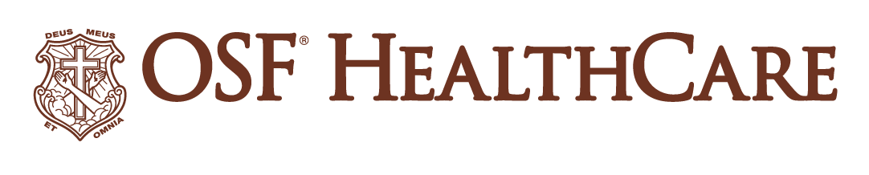
OSF offering low-dose radiotherapy at Danville cancer center
FOR IMMEDIATE RELEASE
Contact: Tim Ditman, media relations coordinator | timothy.r.ditman@osfhealthcare.org | (309) 838-9664
NOTE FOR REPORTERS: A digital version of this release with photos, b-roll and more is available here.
(February 4, 2026 | Danville, Illinois) – OSF HealthCare Bobette Steely Hegeler Cancer Center in Danville, Illinois, is expanding its reach beyond cancer care.
The cancer center is now offering low-dose radiotherapy (LDRT) to treat osteoarthritis and other inflammatory and degenerative conditions of the tendons, joints and soft tissues.
“People who have tried other treatments but are not ready for surgery are great candidates for LDRT,” says Edie Krueger, MD, radiation oncologist at Hegeler Cancer Center. “This is a safe, effective and noninvasive treatment that can significantly reduce pain and stiffness, possibly avoiding the need for surgery.”
Each treatment lasts 15 minutes, and people typically undergo six treatments over two weeks. The person returns in three months for a check-in, and a doctor could recommend another round of treatment. LDRT treatment at Hegeler Cancer Center uses the TrueBeam® linear accelerator. Installed at the cancer center in 2022, the device delivers precise radiation to create a safer, quicker and more comfortable experience for the patient.
People seeking care at Hegeler Cancer Center require a referral from a health care provider, so people interested in LDRT should talk to their care team. If you have general questions about LDRT, call the cancer center at (217) 431-4290. The cancer center is located at 806 N. Logan Ave. in Danville on the campus of OSF Sacred Heart Medical Center.
###
OSF HealthCare is an integrated health system founded by The Sisters of the Third Order of St. Francis and headquartered in Peoria, Illinois. The system includes 18 inpatient facilities encompassing 16 licensed hospitals, two of which operate dual campuses in separate communities. Among these hospitals, 10 are acute care facilities, five are critical access hospitals and one is a continuing care facility. OSF has 2,141 licensed beds throughout Illinois and Michigan and employs more than 27,000 Mission Partners across 170+ locations. These include OSF HealthCare Children’s Hospital of Illinois, the third largest pediatric hospital in the state, and OSF OnCall, its digital health operating entity that offers hospital-at-home care. In addition, OSF operates two colleges of nursing; OSF Home Care Services, an extensive network of home health and hospice services; Pointcore, Inc., which is composed of health care-related businesses; and OSF HealthCare Foundation, the philanthropic arm of the organization. Advances in health care transformation take place through OSF Innovation as well as OSF Ventures, which provides investment capital for promising health care innovation startups. OSF HealthCare has been recognized by Fortune as one of the most innovative companies in the country and by Forbes as one of America’s Best Employers for Healthcare Professionals. Learn more at osfhealthcare.org.
Pronunciations:
Bobette Steely Hegeler (bob-BET // STEE-lee // HEG-eh-ler)
Edie Krueger (EE-dee // KREE-ger)

