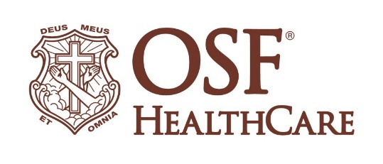
OSF St. Mary Medical Center expands,
remodels emergency department

FOR IMMEDIATE RELEASE
Contact: Matt Sheehan | Media Relations Coordinator | matthew.a.sheehan@osfhealthcare.org
(May 19, 2026 | Galesburg, Illinois) – OSF HealthCare has expanded and renovated the emergency department (ED) at OSF HealthCare St. Mary Medical Center in Galesburg, Illinois. The space has been expanded by 7,000 square feet, adding six additional rooms to accommodate patients.

OSF HealthCare held a Blessing & Dedication of the space on Tuesday, May 19, 2026.

“We are deeply committed to meeting the growing healthcare needs of our community, and this expansion of the emergency department reflects that commitment. By investing in additional space, resources, and capabilities, we are ensuring patients and families have timely access to high-quality emergency care close to home,” says Zach Yoder, President of OSF St. Mary Medical Center. “This dedication is about more than growth. It is about strengthening our ability to serve the community with compassion, excellence and readiness for the future.”

Since the expansion, hospital leaders report a 30% decrease in time for patients to see a provider.

“This will allow us to provide timely, high-quality care for a greater number of patients. Adding a second triage room allows our Advanced Practice Providers (APPs) to evaluate patients from the waiting room without impacting the triage nurse’s ability to efficiently care for patients,” says Nathaniel Baker, MD, managing medical director of emergency medicine with OSF HealthCare St. Mary Medical Center. “This change ensures patients’ care can move forward even while in the waiting room.”

OSF HealthCare leaders, physicians and staff attended, as well as community partners, celebrating this expansion which provides additional care to the Greater Galesburg region. This expansion echoes the commitment of OSF to the Greater Galesburg Area, and across the Ministry.

# # #

OSF HealthCare is an integrated health system founded by The Sisters of the Third Order of St. Francis. Headquartered in Peoria, Illinois, OSF has 17 hospitals – 11 acute care, five critical access and one continuing care – with 2,305 licensed beds throughout Illinois and Michigan. OSF employs over 27,000 Mission Partners across more than 170 locations. These include OSF HealthCare Children’s Hospital of Illinois, the third largest pediatric hospital in the state, and OSF OnCall, its digital health operating entity that offers hospital-at-home care. Advances in health care transformation take place through OSF Innovation as well as OSF Ventures, which provides investment capital for promising health care innovation startups. In addition, OSF operates two colleges of nursing; OSF Home Care Services, an extensive network of home health and hospice services; Pointcore, Inc., which is composed of health care-related businesses; and OSF HealthCare Foundation, the philanthropic arm of the organization. OSF HealthCare has been recognized by Fortune as one of the most innovative companies in the country and by Forbes as one of America’s Best Employers for Healthcare Professionals. Learn more at osfhealthcare.org.

