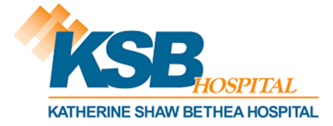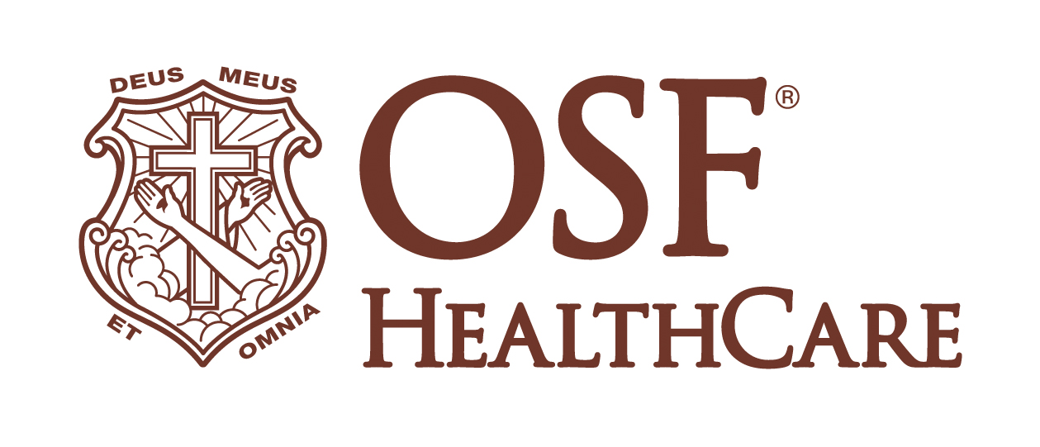

KSB Hospital Celebrates State Approval of Change of Ownership to OSF HealthCare

FOR IMMEDIATE RELEASE
Contact: Paul Arco, Media Relations Coordinator, OSF HealthCare (815) 742-4529

Dixon, IL (September 19, 2024) – KSB Hospital is excited to announce that the Illinois Health Facilities and Services Review Board has officially approved the change of ownership to OSF HealthCare. This pivotal decision marks the beginning of a new chapter for KSB Hospital, promising an even brighter future for health care in the Sauk Valley area.

David Schreiner, President and CEO of KSB Hospital, expressed his enthusiasm for the transition: “We are thrilled to receive the state’s approval, solidifying our partnership with OSF HealthCare. This marks a significant milestone in our journey to enhance the quality of care that our community has come to expect. OSF’s commitment to our mission and values makes them the perfect partner to help us build on our legacy of excellence.”

The process to identify a suitable partner began earlier this year when the KSB Hospital Board of Directors decided to explore affiliation options to secure the hospital's future. After a thorough review and careful consideration, OSF HealthCare was chosen as the best fit for KSB Hospital, a decision met with strong support from both staff and the community.

August Querciagrossa, Regional CEO of OSF HealthCare, shared his excitement about the new partnership: “We are honored to welcome KSB Hospital into the OSF HealthCare family. Our shared commitment to providing compassionate, high-quality care will guide us as we work together to serve the Sauk Valley community. We look forward to building on the strong foundation established by KSB and achieving new milestones in patient care.”

As the transition moves forward, KSB Hospital and OSF HealthCare will collaborate closely to ensure a seamless integration, focusing on maintaining the high standards of care that KSB has always delivered. The community can expect to see enhanced services and continued investments in local health care, reflecting both organizations’ dedication to meeting the needs of the people they serve.

###

