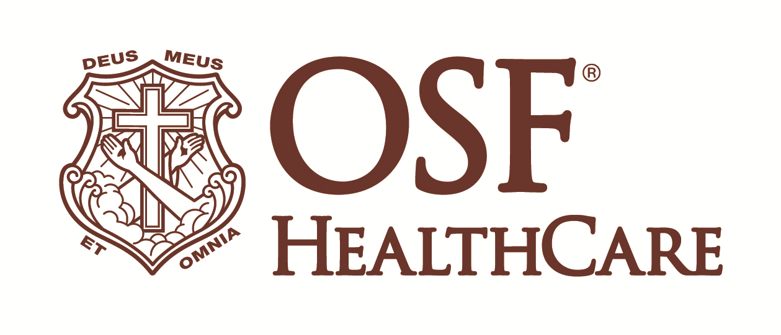

OSF Life Flight marks 40 years of service

Available for immediate release:
Contact: Beau Ebenezer | Public Relations and Communications Coordinator | Beau.R.Ebenezer@osfhealthcare.org

(October 18, 2024 | Peoria, Illinois) - OSF Life Flight, operated by OSF Aviation, LLC, celebrated 40 years of lifesaving service on Friday, October 18. The event marked four decades of critical air-medical transport service throughout Illinois.

The celebration included an open house where attendees toured the OSF Life Flight hangar and viewed the newest addition to its fleet, the D3 Airbus H145 helicopter, making for a total of five state-of the-art helicopters.

Since 1984, OSF Life Flight has provided 24/7 critical care transport, with helicopters now based in Bloomington, Galesburg, Peru, and Rock Falls, Illinois. OSF HealthCare leads the way in air ambulance service in Illinois and operates one of the premier flight programs in the United States. The anniversary celebration underscored OSF Life Flight’s commitment to patient care through advanced technology, a highly skilled team and strong community partnerships.

"This 40-year milestone is a testament to the dedication of our team and the trust we’ve built with the communities we serve," said Kathleen Devine, vice president of OSF Aviation. "The Airbus H145 represents our ongoing mission to deliver top-tier care to patients across Illinois."

For more information, visit OSF Life Flight.

# # #

OSF HealthCare is an integrated health system founded by The Sisters of the Third Order of St. Francis. Headquartered in Peoria, Illinois, OSF HealthCare has 16 hospitals – 10 acute care, five critical access, and one transitional care – with 2,131 licensed beds throughout Illinois and Michigan. OSF employs nearly 24,000 Mission Partners across 150+ locations; has two colleges of nursing; operates OSF Home Care Services, an extensive network of home health and hospice services; owns Pointcore, Inc., comprised of health care-related businesses; OSF HealthCare Foundation, the philanthropic arm for the organization; and OSF Ventures, which provides investment capital for promising health care innovation startups. In 2020, OSF OnCall was established as a digital health operating unit, including a hospital-at-home. OSF OnCall delivers care and services when, where and how patients prefer to receive them. OSF HealthCare has been recognized by Fortune as one of the most innovative companies in the country. More at osfhealthcare.org.

