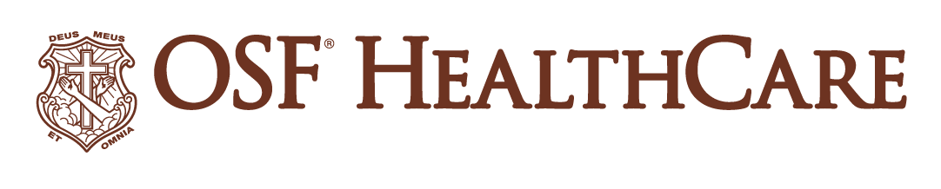
OSF HealthCare St. Francis Hospital & Medical Group opens new cancer clinic
OSF HealthCare Daniel J. Kobasic Cancer Clinic will provide oncology and hematology services starting May 20

For immediate release
Contact: Paul Arco - Media Relations Coordinator | (815) 395-5036 | Paul.A.Arco@osfhealthcare.org
(MAY 17, 2024 | ESCANABA, Michigan) – The new OSF HealthCare Daniel J. Kobasic Cancer Clinic will welcome its first
patients starting May 20.

The new clinic, located at OSF St. Francis Hospital & Medical Group, offers expanded oncology and hematology services for current and future patient care needs. The clinic features additional space for a larger arrival and waiting area, enhanced patient care areas including five examination rooms and 10 infusion bays with windows and iPads, nurse navigator services and on-site support services. OSF relocated oncology services from its current location within the OSF Medical Office Building to a larger, separate building on the hospital campus.

In 2022, OSF St. Francis was awarded $1.5 million in federal funds through a government funding bill that U.S. Senator Gary Peters helped pass into law. Through Senator Peters’ support, this funding became the basis for the project, allowing the OSF HealthCare Foundation to move forward with a capital fundraising campaign in which a gift of $1 million was made by the Daniel J. Kobasic Foundation.

“We are thrilled that this day has finally arrived,” says Kelly Jefferson, president of OSF St. Francis. “We are truly grateful to Senator Peters, the Daniel J. Kobasic Foundation and the many donors for their commitment to Delta County and the patients we serve. This beautiful facility will serve our community for many years to come.”

Oncology services at OSF St. Francis are provided through a collaboration between OSF and Green Bay Oncology, a relationship that has served the local community since 1994.

###

OSF HealthCare is an integrated health system founded by The Sisters of the Third Order of St. Francis. Headquartered in Peoria, Illinois. OSF HealthCare has 16 hospitals – 10 acute care, five critical access, one transitional care - with 2,131 licensed beds throughout Illinois and Michigan. OSF employs nearly 24,000 Mission Partners across 150+ locations; has two colleges of nursing; operates OSF Home Care Services, an extensive network of home health and hospice services; owns Pointcore, Inc., comprised of health care-related businesses; OSF HealthCare Foundation, the philanthropic arm for the organization; and OSF Ventures, which provides investment capital for promising health care innovation startups. In 2020, OSF OnCall was established, a digital health operating unit, including a hospital-at-home. OSF OnCall delivers care and services when, where and how patients prefer to receive them. OSF HealthCare has been recognized by Fortune as one of the most innovative companies in the country. More at osfhealthcare.org

