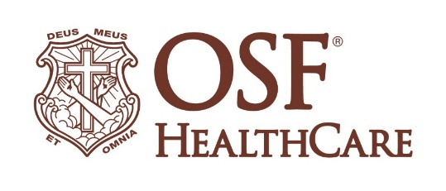
OSF HealthCare launches Saturday morning sports injury clinic

Contact: Beau Ebenezer | Public Relations and Communications Coordinator | Beau.R.Ebenezer@osfhealthcare.org
(September 3, 2025 | Peoria, Illinois) – OSF HealthCare is joining Great Plains Orthopaedics to offer a walk-in orthopedic sports injury clinic every Saturday through October 25, from 8 a.m. to noon, at OSF Center for Health on Route 91 in Peoria.

The clinic provides a convenient, direct pathway to specialized care for athletes experiencing sports-related injuries. Instead of first visiting urgent care or prompt care facilities and then being referred to OSF Orthopedics, injured athletes can walk directly into the Saturday clinic and be seen by an orthopedic specialist.

Patients should enter through the main entrance and proceed to the OSF Orthopedics office on the fourth floor.

# # #

OSF HealthCare is an integrated health system founded by The Sisters of the Third Order of St. Francis. Headquartered in Peoria, Illinois, OSF HealthCare has 17 hospitals – 11 acute care, five critical access, one continuing care – with 2,305 licensed beds throughout Illinois and Michigan. OSF employs more than 26,000 Mission Partners across 160+ locations and includes OSF OnCall, the digital health operating entity which offers a hospital-at-home. Advances in health care transformation take place through OSF Innovation and OSF Children’s Hospital of Illinois, the third largest pediatric hospital in Illinois, cares for our smallest patients. In addition, OSF has two colleges of nursing; operates OSF Home Care Services, an extensive network of home health and hospice services; owns Pointcore, Inc., comprised of health care-related businesses; OSF HealthCare Foundation, the philanthropic arm for the organization; and OSF Ventures, which provides investment capital for promising health care innovation startups. OSF HealthCare has been recognized by Fortune as one of the most innovative companies in the country. More at osfhealthcare.org.

