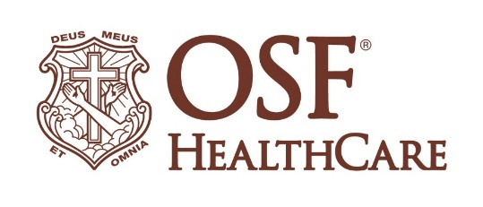
OSF Richard L. Owens Hospice Home unveils beacon of light

FOR IMMEDIATE RELEASE
Contact: Beau Ebenezer | Public Relations and Communications Coordinator | Beau.R.Ebenezer@osfhealthcare.org
(October 23, 2025 | Peoria, Illinois) – A new beacon now shines above the OSF Richard L. Owens Hospice Home, honoring those who have received compassionate end-of-life care and those who have passed since the facility opened in 2013.

On Wednesday, October 22, OSF HealthCare leaders and community members gathered for the unveiling of the Hospice Beacon of Light. The single beam, visible from dusk until 2 a.m., symbolizes comfort, peace and remembrance for patients and families served by the hospice home.

The light was made possible through a generous donation from the wife of a former patient, who wanted to create a lasting tribute to the care her husband received. Since its opening, OSF Richard L. Owens Hospice Home has served thousands of patients and families across central Illinois, providing medical, emotional and spiritual support during life’s final journey.

Photos and video from the event are available on the OSF HealthCare Newsroom.

# # #

OSF HealthCare is an integrated health system founded by The Sisters of the Third Order of St. Francis. Headquartered in Peoria, Illinois, OSF has 17 hospitals – 11 acute care, five critical access and one continuing care – with 2,305 licensed beds throughout Illinois and Michigan. OSF employs over 27,000 Mission Partners across more than 170 locations. These include OSF HealthCare Children’s Hospital of Illinois, the third largest pediatric hospital in the state, and OSF OnCall, its digital health operating entity that offers hospital-at-home care. Advances in health care transformation take place through OSF Innovation as well as OSF Ventures, which provides investment capital for promising health care innovation startups. In addition, OSF operates two colleges of nursing; OSF Home Care Services, an extensive network of home health and hospice services; Pointcore, Inc., which is composed of health care-related businesses; and OSF HealthCare Foundation, the philanthropic arm of the organization. OSF HealthCare has been recognized by Fortune as one of the most innovative companies in the country and by Forbes as one of America’s Best Employers for Healthcare Professionals. Learn more at osfhealthcare.org.

