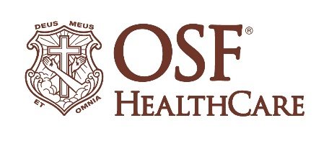
OSF HealthCare Breaks Ground for OSF Cancer Center Technology in Bloomington

For immediate release
Contact: Libby Allison | OSF HealthCare Media Relations Coordinator | (309) 308-5015

(March 4, 2021 | Bloomington, IL) – OSF HealthCare is wholly committed to convenient access to cancer services for the communities it serves. As part of that commitment, OSF leaders broke ground Thursday, March 4, on an important component of the OSF Cancer Center in Bloomington.

Thursday’s groundbreaking took place at at the future site of OSF Cancer Center’s new radiation technology, the TrueBeam system, by Varian Medical Systems. TrueBeam is a state-of-the-art system that will provide accurate and comprehensive radiation treatment for the Bloomington-Normal community. It combines imaging, beam delivery and sophisticated motion management to accurately and precisely target tumors with speed.

“As we look at cancer services there are two key parts: the technology that supports the latest evidence-based treatments, and the support - how well we journey with our patients,“ remarked Lynn Fulton, president, OSF HealthCare. “Today we celebrate the ground breaking for the Varian TrueBeam Linear Accelerator. It is an amazing piece of technology that improves precision and accuracy while increasing speed, which decreases treatment time.”

“The technology is great, but there has to be support for our patients and their family,” continued Fulton. “A cancer diagnosis is devastating. Having experienced it with my mom and my father-in-law, I know that the family’s journey is hard and the destination is not always known. It is our intention at OSF to ease their way so that they can spend more time as a family and less time wondering about what happens next. Our nurse navigator and our pastoral care support are here to partner with them throughout and minimize the unknowns. I believe it is important for our patients to know that we commit to providing both parts – the latest technology to support evidence based treatment and assure them that we will be here to support them throughout the journey.”

The new OSF Cancer Center is schedule to be completed in September with access to the Varian TrueBeam linear accelerator. It will join the many offerings currently available. Today our patients have convenient access to myriad of cancer treatments and services, including:

- Tumor board to support the latest treatment options
- Radiation treatment through the Halcyon
- Nurse navigation services and support
- Infusion therapy
- Spiritual Care through dedicated Pastoral Care Provider
- Access to Genetic Counseling and Clinical Trials

The new OSF Cancer Center will be located on the first floor of OSF Center for Health at 210 St. Joseph Drive. OSF Cancer Center at OSF St. Joseph is connected to the overall OSF cancer services based out of OSF Saint Francis in Peoria. This provides patients with increased treatment options as well as opportunities for participation in clinical trials. Our physicians will be able to collaborate real-time with their counterparts in Peoria.

-30-

