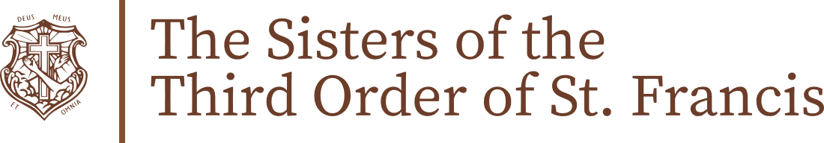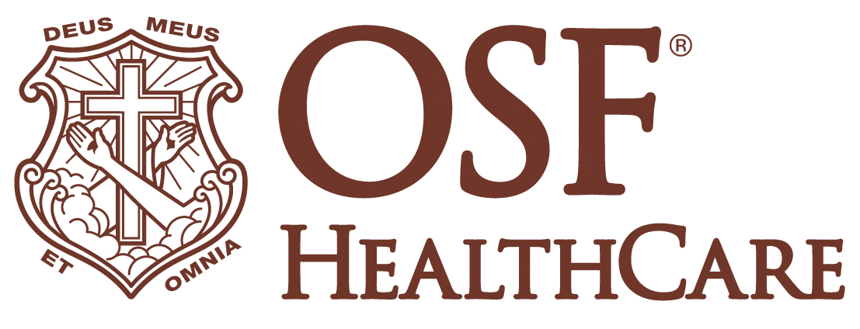

OSF HealthCare welcomes new leadership team for
The Sisters of the Third Order of St. Francis

FOR IMMEDIATE RELEASE
Contact: Shelli Dankoff, Media Relations and Multi-Media Manager, OSF HealthCare | (309) 634-8583
Peoria, IL (October 7, 2024) – OSF HealthCare is pleased to announce the appointment of Sister Agnes Joseph Williams, O.S.F., as the new Major Superior of The Sisters of the Third Order of St. Francis, effective October 6. Joining her in leadership for the next six years are Sister Judith Ann Duvall, O.S.F., Sister Theresa Ann Brazeau, O.S.F., Sister Rose Therese Mann, O.S.F., and Sister Teresa Paul Selamat, O.S.F., who will serve as her council in guiding the Mission and Ministry of OSF HealthCare.

Sister Agnes Joseph succeeds Sister Judith Ann, who has faithfully led The Sisters for the past 18 years. Under Sister Judith Ann’s leadership, OSF HealthCare has grown into one of the largest Catholic health systems in Illinois, staying true to its Mission of serving with the greatest care and love. Her unwavering commitment to our faith-driven Ministry has left an indelible mark on the communities we serve.

"We are deeply grateful to Sister Judith Ann for her remarkable leadership, devotion, and vision," said Sister Agnes Joseph. "Her legacy is one of compassionate service, and we will continue to build on the foundation she has laid as we move forward into the future with renewed energy and faith.

“I am very honored that my Sisters have chosen me as their new Major Superior. I want to serve each of them with the greatest care and love and to grow with them on our spiritual journeys in our love of God and the service of each other,” Sister Agnes Joseph said. “Our health care system and each and every one of our Mission Partners are special gifts that God has entrusted to our Community. We will continue to embrace our responsibilities to govern and guide OSF HealthCare according to His will and to care for all those serving with us to the best of our abilities.”

Sister Judith Ann expressed her gratitude for serving as Major Superior for the past 18 years. “I was blessed to serve my Sisters and for all their love and support and prayers for me. It was a journey I will always cherish,” she said. “I am humbled and delighted that I will be able to continue being a member of the Governing Board of our Religious Community for the next six years.”

Sister Agnes Joseph holds a Bachelor of Science degree in Mathematics and a Master of Business Administration from the University of Akron. She serves on the OSF Boards and is on the Saint Francis Medical Center College of Nursing Board. Alongside her council, she will lead OSF HealthCare with a focus on the continuity of the OSF HealthCare Mission. Their combined experience and dedication will ensure that OSF continues to uphold the longstanding values and principles established by its founders, reinforcing its commitment to providing compassionate care and service to all communities.

"We are excited to welcome Sister Agnes Joseph and her council into their new roles," said Robert Sehring, CEO of OSF HealthCare. "Their leadership, grounded in faith and service, will continue to guide OSF HealthCare as we carry out our Mission to serve with the greatest care and love."

For additional media assets for the leadership transition, visit the OSF Newsroom.

# # #

