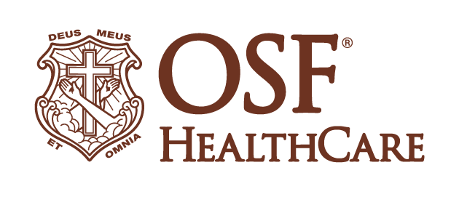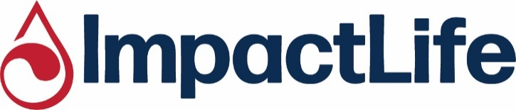
Eureka-Goodfield EMS becomes first Illinois ground ambulance to carry blood
(January 14, 2026 | Eureka–Goodfield, Illinois) - When Eureka-Goodfield EMS arrives on scene for a bleeding patient, the difference between life and death can be minutes. Thanks to collaboration with OSF HealthCare and ImpactLife, Eureka-Goodfield EMS has become the first ground ambulance service in Illinois to carry blood components on board, allowing patients to receive transfusions before reaching the hospital.
The pre-hospital transfusion program began Monday, when Eureka-Goodfield EMS received two units of type O-positive red blood cells and two units of plasma from the ImpactLife distribution hub in Peoria. Two Eureka-Goodfield EMS ambulances will now always carry red blood cells and plasma.
Matthew Jackson, MD, medical director of pre-hospital and EMS at OSF HealthCare, also serves as medical director for Eureka-Goodfield EMS and Peoria Area EMS. He helped shape the pre-hospital transfusion program for Eureka-Goodfield, the first ground ambulance service in Illinois to carry blood components on board its ambulances. He describes pre-hospital transfusion as a growing area of patient care that lies at the intersection of emergency medical service and transfusion medicine.
“Bleeding from an uncontrolled hemorrhage is a leading cause of preventable death among trauma patients,” Jackson said. “Every minute counts for these patients, so receiving blood products from trained first responders can significantly improve survival, reduce the length of hospital stays and help decrease the overall use of blood once patients arrive at the emergency department.”
“We are truly honored and excited to be the first ground-based EMS service to carry blood in Illinois,” said Eureka-Goodfield EMS Division Chief Randy Wolfe. “This milestone reflects Eureka-Goodfield EMS’ commitment to innovation and patient care. Carrying blood on our ambulances allows our medics to deliver critical lifesaving care sooner, closing the gap between rural emergencies and definitive care for the entire region.”
January is National Blood Donor Month
ImpactLife provides blood components used by 26 air and ground ambulance services in Illinois, Iowa, Missouri and Wisconsin. Eureka-Goodfield EMS is served by the ImpactLife distribution hub in Peoria, which also provides blood components for OSF HealthCare Saint Francis Medical Center, Carle Health Methodist Hospital, Graham Health System in Canton, and OSF and Carle hospitals in Galesburg, Bloomington, and Urbana.
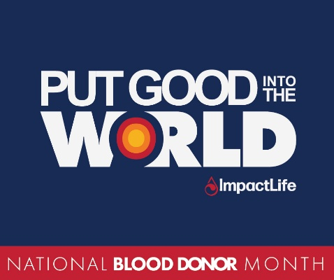
ImpactLife invites communities across its service region to Put Good Into the World as supporters of our region's blood supply in 2026. This January, ImpactLife joins blood providers across the U.S. in celebrating blood donors, blood drive coordinators, and volunteers during January's National Blood Donor Month.
The first National Blood Donor Month was recognized in 1970, following a proclamation by President Richard Nixon and a Joint Resolution of the U.S. Congress. The month-long recognition pays tribute to volunteer blood donors and encourages new donors to join the cause during a season that can present some of the greatest challenges for our region’s blood supply. Extreme weather, seasonal illness, and the need to recover donations lost during the busy holiday season all contribute to the challenges blood providers face during the month of January.
The blood center invites donors to support the region’s blood supply by scheduling appointments for donation at its Peoria Donor Center and on mobile blood drives held across central Illinois. To book an appointment, call ImpactLife at (800) 747-5401, visit www.bloodcenter.org, or download the ImpactLife mobile app at www.bloodcenter.org/app.
-end-
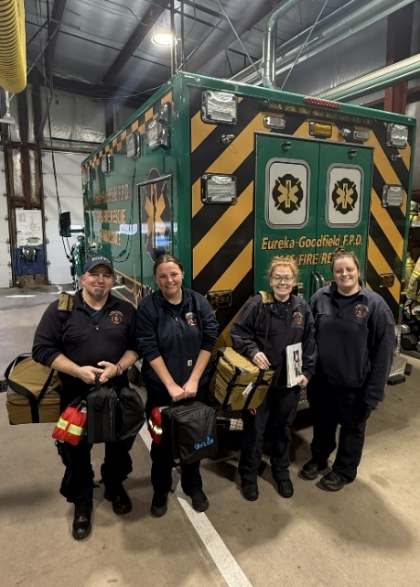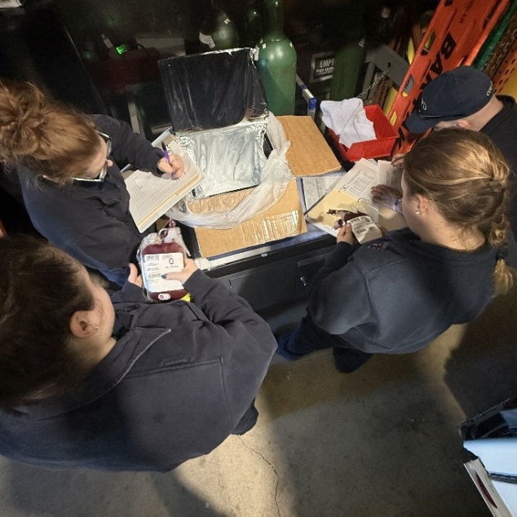
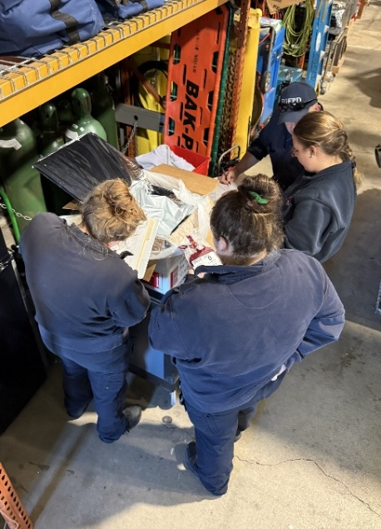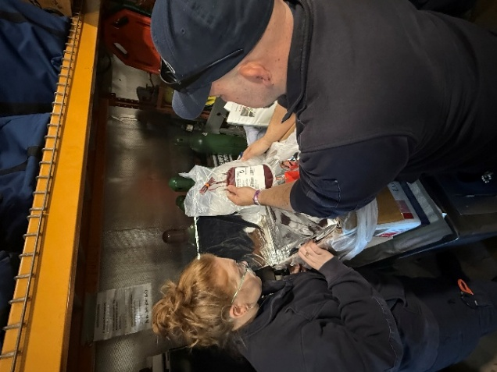
Pictured, left to right in photo at upper left: Mark Cornell, Expanded-Scope Paramedic; Kaylie Wettstein, EMT; AJ Lesher, Expanded-Scope Paramedic; Hanna Gerber, Expanded-Scope Paramedic

