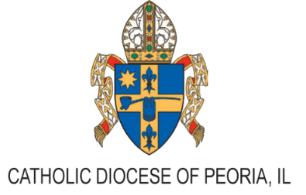
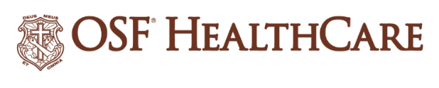

OSF HealthCare Transitions to New Governance Model:
OSF Healthcare Ministries Established

For Immediate Release
Contact: Shelli Dankoff | OSF HealthCare Media Relations Manager | (309) 634-8583

(Peoria, Ill.| October 30, 2024) – OSF HealthCare is pleased to announce the official establishment of OSF Healthcare Ministries as a Diocesan Public Juridic Person (Diocesan PJP), in partnership with the Catholic Diocese of Peoria. OSF Healthcare Ministries will now serve as the sole corporate member and canonical sponsor of OSF Healthcare. This marks an important milestone for the organization, ensuring a strong foundation for the continued delivery of exceptional, faith-based care.

The Holy See has approved this transition and Most Reverend Bishop Louis Tylka has issued a decree officially designating OSF Healthcare Ministries a Diocesan PJP. The Sisters of the Third Order of St. Francis, who have been integral to the health care Ministry for over 147 years, will continue to play a vital role in this new structure.

The OSF Healthcare Ministries Board will include five Sisters: Sister Agnes Joseph Williams, O.S.F., Major Superior; Sister Judith Ann Duvall, O.S.F.; Sister Theresa Ann Brazeau, O.S.F.; Sister Rose Therese Mann, O.S.F.; and Sister Teresa Paul Selamat, O.S.F. Their leadership ensures that OSF HealthCare remains committed to its Mission to serve with the greatest care and love.

"This transition reflects our ongoing dedication to exceptional health care while honoring Catholic values," said Bishop Tylka. "OSF Healthcare Ministries will enable us to maintain the care that OSF Healthcare provides to the 26 counties within the Diocese of Peoria and beyond."

Sister Agnes Joseph, O.S.F. stated, "Transitioning OSF Healthcare System to OSF Healthcare Ministries is a profound affirmation of our commitment to our Mission, and we look forward to continuing our legacy of care rooted in faith."

The establishment of OSF Healthcare Ministries is a strategic decision, as both the Sisters’ Motherhouse and OSF Ministry Headquarters are located in the Peoria area. This new model reinforces the longstanding relationship between the Sisters and the Bishops of the Peoria Diocese, who have supported and collaborated with the Sisters since the inception of the Ministry in 1877.

While OSF HealthCare operates across multiple dioceses in Illinois and Michigan, the establishment of the Diocesan PJP within the Diocese of Peoria underscores the commitment to local communities. This change will not impact the daily operations of OSF HealthCare, ensuring that Mission Partners, patients, and donors will continue to receive the same high-quality care they have come to expect.

For more information about OSF HealthCare and its commitment to faith-based health care, visit osfhealthcare.org.

###

