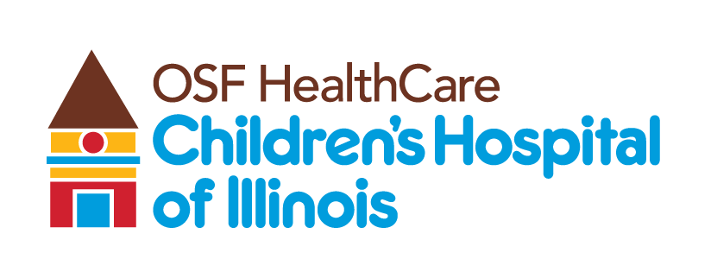
4-year-old makes miraculous recovery at OSF Children's Hospital after bicycle crash
FOR IMMEDIATE RELEASE
Contact: Beau Ebenezer | Public Relations and Communications Coordinator | Beau.R.Ebenezer@osfhealthcare.org
(August 11, 2026 | Peoria, Illinois) – What began as every parent's worst nightmare has become a remarkable story of survival, expert pediatric care and recovery at OSF HealthCare Children's Hospital of Illinois.
In May 2026, 4-year-old Cal McCallister was riding his bicycle at his grandmother's home in Rock Falls when he lost control on a steep hill and entered the roadway. He was struck by a vehicle traveling approximately 50 mph, suffering a severe traumatic brain injury with bleeding and swelling in his brain.
Emergency responders quickly arrived, and an OSF Life Flight helicopter transported Cal to OSF HealthCare Children's Hospital of Illinois, the region's only Level I Pediatric Trauma Center, where pediatric trauma, neurosurgery and critical care specialists immediately began lifesaving treatment.
Cal spent several weeks in the Pediatric Intensive Care Unit, undergoing multiple procedures, including three craniectomies to relieve pressure on his brain. Despite the severity of his injuries, he exceeded expectations and was eventually discharged to continue rehabilitation.
"Time is of the essence, especially with very sick patients," said Madhuradhar Chegondi, MD, pediatric critical care physician at OSF HealthCare Children's Hospital of Illinois. "One of the key factors in this child's positive outcome was getting early to the right facility at the right time."
Cal's father, Cory McCallister, said the outcome is more than his family could have hoped for.
"The progress he has made is unreal," McCallister said. "The severity of his injuries, he is doing better than we were told and what we expected. He is a miracle baby."
The complete story follows Cal's journey from the crash through his hospitalization and recovery, highlighting the collaborative care provided by the multidisciplinary team at OSF Children's Hospital and the support his family received throughout the experience.
To learn more, watch the full Meg's Marvels episode featuring Cal's story on YouTube: [INSERT YOUTUBE LINK]. Media can also visit the OSF Newsroom for additional soundbites, B-roll, photos and the complete story: [INSERT NEWSROOM LINK].
Members of the media interested in scheduling additional interviews may contact J.D. Raucci, Public Relations and Communications Manager, at JohnDavid.Raucci@osfhealthcare.org.
###
About OSF HealthCare Children's Hospital of Illinois:
Located in Peoria, OSF HealthCare Children's Hospital of Illinois is the third largest pediatric hospital in Illinois and the most comprehensive hospital for kids downstate. With 136 beds and more than 140 pediatric subspecialists, OSF Children's Hospital cares for more children in Illinois than any hospital outside of Chicago. Formally established as a pediatric hospital within the walls of OSF HealthCare Saint Francis Medical Center in 1990, OSF Children's Hospital of Illinois has more than 7,000 inpatient admissions, 75,000 outpatient specialty visits, 2,400 newborn deliveries and 18,000 emergency department visits each year. Learn more by visiting https://www.osfhealthcare.org/hospitals/childrens.

