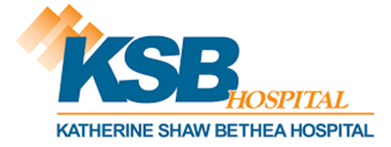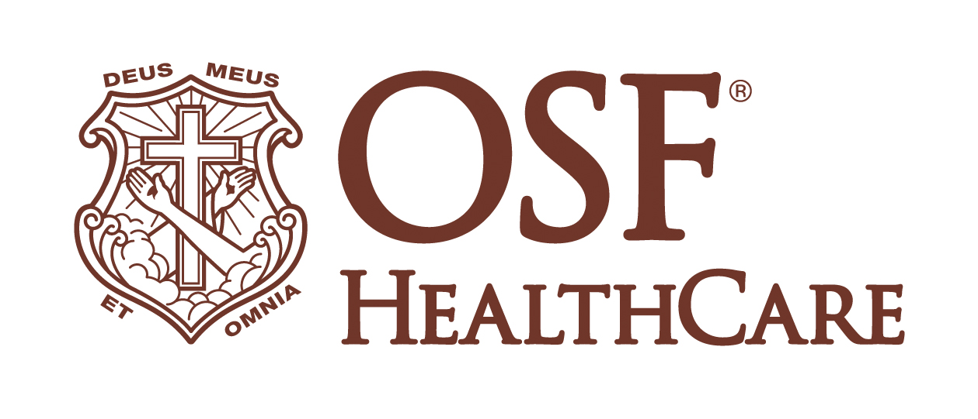

KSB Hospital to be Renamed OSF Saint Katharine Medical Center, Honoring Its Legacy and Embracing the Future

FOR IMMEDIATE RELEASE
Contact: Paul Arco, Media Relations Coordinator, OSF HealthCare (815) 395-5036

Dixon, IL (September 25, 2024) – KSB Hospital, a cornerstone of the Dixon community for more than a century, is set to enter a new era with a fresh name that reflects its rich history and its future with OSF HealthCare. The hospital, originally named Katherine Shaw Bethea Hospital in 1897 when Judge Solomon Bethea donated his estate to honor his late wife Katherine, will soon be known as OSF Saint Katharine Medical Center. The new name pays tribute to the hospital’s long-standing commitment to the Sauk Valley region and aligns with the values of OSF HealthCare.

David Schreiner, President and CEO of KSB Hospital, said the name change is both a nod to the hospital’s history and a promise of continued dedication to the community. “This new name is a tribute to our legacy of service and represents a significant step forward as we join the OSF HealthCare family,” Schreiner said. “We are proud of our past and excited about the future as we continue our mission to provide exceptional care.”

The name change comes after the Illinois Health Facilities and Services Review Board approved the hospital’s change of ownership to OSF HealthCare, a decision met with broad support from both staff and local residents. The new name, OSF Saint Katharine, not only honors the memory of Katherine Shaw Bethea but also incorporates the hospital’s mission to enhance health care access and quality for the community.

August Querciagrossa, Regional CEO of OSF HealthCare, expressed enthusiasm about the integration: “Welcoming KSB Hospital into the OSF HealthCare family is a profound honor. The new name symbolizes our commitment to carrying forward the values and high standards that KSB has long embodied, and it underscores our shared vision for the future of health care in the region.”

The new name will officially be unveiled this winter, and the hospital’s leadership invites the community to participate in this momentous change. The new name and logo are more than just a rebranding effort; they symbolize a recommitment to the compassionate, high-quality care that has defined KSB for over 125 years.

As KSB Hospital embarks on this new chapter, the spirit of its founding will continue to inspire its mission, ensuring that the dedication to health and service remains stronger than ever.

###

