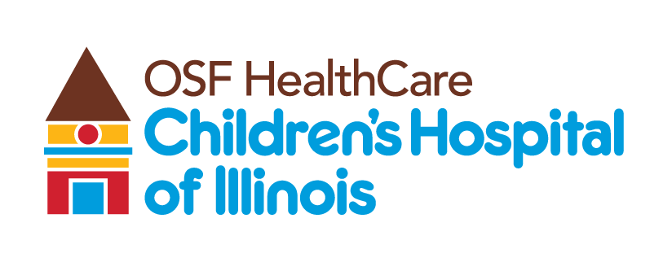
OSF Children’s Hospital first in region with “smart” cochlear implant

Contact: Beau Ebenezer | Public Relations and Communications Coordinator | Beau.R.Ebenezer@osfhealthcare.org
(October 29, 2025 | Peoria, Illinois) – OSF HealthCare Children’s Hospital of Illinois is leading pediatric hearing care in Central Illinois as the first facility in the region to use the Cochlear™ Nucleus® Nexa™ System, the world’s first “smart” cochlear implant system.

John Greinwald Jr., MD, otolaryngologist at OSF Children’s Hospital, performed the first implants this month, giving local children access to the latest technology sooner than patients at other hospitals in the region.

The Cochlear Nucleus Nexa System features upgradable firmware, internal rewritable memory, and dynamic power management. These innovations allow patients to receive software updates and future improvements without the need for additional surgery. The system also securely stores a user’s unique hearing information, or MAPs, so it can be transferred to a new sound processor if needed. The system includes the smallest and lightest sound processors with all-day battery life, adaptive sound processing for clearer hearing in different environments, and a connected ecosystem for ongoing care and support.

OSF Children’s Hospital continues to establish itself as a surgical destination for pediatric care, providing access to the latest medical technology and specialized expertise for children and families throughout Central Illinois.

B-roll and interviews can be found on the OSF Newsroom.

# # #

About OSF HealthCare Children’s Hospital of Illinois:
Located in Peoria, OSF HealthCare Children’s Hospital of Illinois is the third largest pediatric hospital in Illinois and the most comprehensive hospital for kids downstate. With 136 beds and more than 140 pediatric subspecialists, OSF Children’s Hospital cares for more children in Illinois than any hospital outside of Chicago. Formally established as a pediatric hospital within the walls of OSF HealthCare Saint Francis Medical Center in 1990, OSF Children’s Hospital of Illinois has more than 7,000 inpatient admissions, 75,000 outpatient specialty visits, 2,400 newborn deliveries, and 18,000 emergency department visits each year. Learn more by visiting childrenshospitalofillinois.org.

