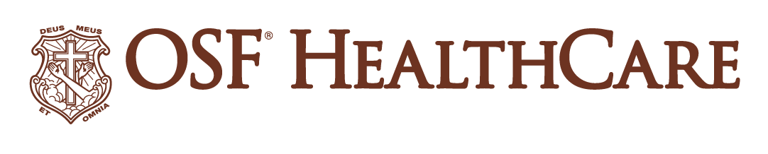
OSF HealthCare offers new approach to primary care on Chicago’s southside
OSF CompleteCare 55+ is aimed at people who want a more personalized, convenient experience managing ongoing health conditions
For immediate release
Media Contact: Colleen Reynolds | Media Relations Coordinator, OSF HealthCare | mobile: (309) 825-7255
(June 11, 2024/Evergreen Park, Ill.) – Leaders from OSF HealthCare and OSF OnCall, the digital health arm of OSF HealthCare, gathered for a blessing of a new clinic that provides an innovative approach to 55+ primary care for people who have ongoing health conditions. The OSF CompleteCare 55+ clinic fills a 6,300-square-foot building at 9858 S. Western Ave., in Evergreen Park. The clinic will begin seeing patients June 16.
This unique approach to care provides guidance and education beyond routine visits and 24/7 digital connection to a care team to allow people to stay on top of their own health.
Highlights of the unique features:
- In-person or virtual visits, including extended and after-hours care
- 24/7 access to your care team and digital health monitoring tools
- Help with appointment scheduling and coordination, insurance referrals and pre-visit planning to maximize time with their provider
- On-site labs for convenience
- Personalized care plans with group education and support to better understand your health conditions
OSF CompleteCare 55+ is a service of OSF HealthCare Little Company of Mary Medical Center.
The facility features:
- Lobby area with coffee bar, fireplace and USB plug-ins
- A Connect Bar for education where navigators will help patients set up Bluetooth wearables or communication devices
- 12 exam and treatment rooms equipped for virtual visits
- Opportunities for group visits, group education, or support with device technology or remote patient monitoring equipment.
- Family consult room for private discussions that can include extended family or support individuals
“Many people 55 and older are balancing the responsibilities of caring for children, grandchildren and elderly parents, while still working themselves,” says Kathleen Kinsella, president of OSF Little Company of Mary. “This age group is busy! Because of that, their own health care needs often take a back seat. That’s why we created a new kind of primary care that offers appointments outside of traditional business hours, virtual options and care coordinators who can help you make connections to specialists when needed.”
Kate Barth, chief nursing officer and vice president, On Demand Services, OSF OnCall, says in designing the program, OSF held listening sessions with 55 and older community members about what features they would like to see in a new approach to primary care.
“We learned people want a choice of in-person or virtual visits, onsite lab services, help with care coordination and pre-visit coordination to maximize time with medical providers,” Barth shares. “Care navigators can also help deal with insurance issues, coordinating appointments with specialists, and extended clinic hours were features that came out of those listening sessions.”
Sandy Valino Stock, DO, is the medical director of the new OSF CompleteCare 55+ clinic. She has cared for patients with complex chronic conditions for more than 17 years through traditional primary care and concierge medicine models. She is passionate about serving communities and optimizing her patients’ health through a personalized, proactive approach. Dr. Valino Stock stresses CompleteCare 55+ strives to keep an aging population healthy and navigate the complex health care system when they are sick.
“The new model from OSF HealthCare differentiates itself from other primary care models by using a team approach to care for patients with multiple medical conditions. OSF CompleteCare 55+ utilizes technology to provide remote patient monitoring, 24/7 telemedicine support, while personalizing a patient’s health care journey. Chronic conditions such as diabetes, high blood pressure, and heart disease take a toll on not only the patients but also those who care for them. Our team at OSF CompleteCare 55+ eases these challenges.”
Here's the website for more information, including frequently asked questions or to get started with OSF CompleteCare 55+.
# # #
OSF HealthCare is an integrated health system founded by The Sisters of the Third Order of St. Francis. Headquartered in Peoria, Illinois, OSF HealthCare has 16 hospitals – 10 acute care, five critical access, one transitional care - with 2,131 licensed beds throughout Illinois and Michigan. OSF employs nearly 24,000 Mission Partners across 150+ locations; has two colleges of nursing; operates OSF Home Care Services, an extensive network of home health and hospice services; owns Pointcore, Inc., comprised of health care-related businesses; OSF HealthCare Foundation, the philanthropic arm for the organization; and OSF Ventures, which provides investment capital for promising health care innovation startups. In 2020, OSF OnCall was established, a digital health operating unit, including a hospital-at-home. OSF OnCall delivers care and services when, where and how patients prefer to receive them. OSF HealthCare has been recognized by Fortune as one of the most innovative companies in the country. Learn more at osfhealthcare.org.
OSF OnCall, part of Peoria, Illinois-based OSF HealthCare, offers unique, full-scale digital health and convenient care options. Providing an array of services anytime, anywhere, OSF OnCall includes digital platforms and software to connect people with care 24/7 using smartphone apps, text-based check-ins and video visits with live support. OSF OnCall Urgent Care offers in-person or virtual visits for minor injuries and illness. OSF OnCall Connect supports people through digital and at-home care. OSF OnCall also represents other at-home and hospital-based digital care including remote monitoring, intensive care and hospitalist programs, as well as a digital hospital option. Learn more at osfoncall.org.

