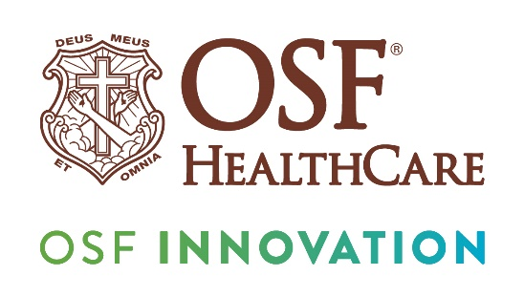

OSF HealthCare announces Simulationist of the Year for 2025

FOR IMMEDIATE RELEASE

Contact: Colleen Reynolds, Media Relations Coordinator | cell (309) 825-7255
(Sept. 15, 2025 |PEORIA, Illinois) – Jacob Wilson, simulation specialist at OSF HealthCare, has received the OSF HealthCare 2025 Simulationist of the Year award. The award recognizes Wilson’s outstanding contributions to advancing medical education, improving clinical operations, and enhancing patient care. Wilson is described by his nominator as having “unwavering commitment to improving simulation-based training, fostering a culture of continuous improvement and sharing the next generation of clinicians.”

Wilson has been instrumental in transforming the simulation experience for medical students and faculty. By leading the transition to the Gaumard simulator platform, he ensured reliable, high-fidelity technology that allows for standardized and repeatable training. This shift has reduced equipment downtime and interruptions, creating smoother educational sessions that help students focus on decision-making and clinical reasoning.

“Jake’s dedication to innovation and excellence in simulation has had a direct impact on both education and patient care. He embodies professionalism, curiosity and collaboration, making him a true leader in the field of medical education.” –- Chris Larkner, manager, OSF Jump Trading Simulation & Education Center.

“There were several great nominees and some very good talent there so I’m very honored to have been picked among the six nominees,” Wilson said in accepting the award. What does he love about his job as a simulationist? “Seeing in person the impact we’re making with education and how simulation helps everyone, from new nurses to well-seasoned physicians and helping them further their education.”

In his role coordinating third and fourth year medical student immersion experiences at Jump Simulation, Wilson streamlined workflows for both learners and faculty. His meticulous preparation and organization allow sessions to run efficiently, with faculty able to focus on teaching while students practice critical skills in an uninterrupted, high-quality learning environment. His integration of platforms such as Monday.com has further improved scheduling, accountability and internal workflows, increasing efficiency across the simulation team.
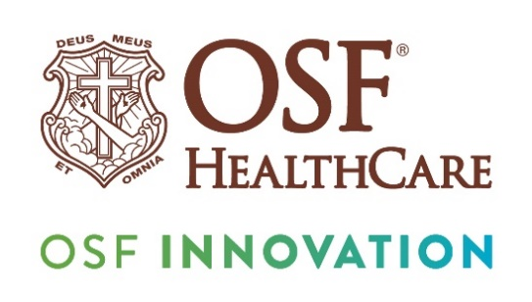

Wilson’s leadership extends nationally, as demonstrated by his key role in the successful execution of the 2025 SimOps conference, where his work was recognized by the Society for Simulation in Healthcare (SSH). Within Jump Simulation, faculty frequently request his support by name, reflecting the trust and respect he has earned among peers, colleagues and leadership.

# # #

OSF HealthCare is an integrated health system founded by The Sisters of the Third Order of St. Francis. Headquartered in Peoria, Illinois, OSF HealthCare has 17 hospitals – 11 acute care, five critical access, one continuing care – with 2,305 licensed beds throughout Illinois and Michigan. OSF employs more than 26,000 Mission Partners across 160+ locations and includes OSF OnCall, the digital health operating entity which offers a hospital-at-home. Advances in health care transformation take place through OSF Innovation and OSF Children’s Hospital of Illinois, the third largest pediatric hospital in Illinois, cares for our smallest patients. In addition, OSF has two colleges of nursing; operates OSF Home Care Services, an extensive network of home health and hospice services; owns Pointcore, Inc., comprised of health care-related businesses; OSF HealthCare Foundation, the philanthropic arm for the organization; and OSF Ventures, which provides investment capital for promising health care innovation startups. OSF HealthCare has been recognized by Fortune as one of the most innovative companies in the country. More at osfhealthcare.org.

Jump Simulation, a part of OSF HealthCare and the University of Illinois College of Medicine Peoria, is a state-of-the-art medical simulation center dedicated to improving outcomes and lowering health care costs through innovative education and training.

